THE JOHN HAMPDEN SCHOOL WENDOVER – SCHOOL UNIFORM ORDER FORM

CHILD’S NAME …………………………………………………………………………………….

Item |  |  | Price | Quantity | Size | Colour  (Please state which colour you would like) | Total cost
Grey Trousers (age 3/4, 4/5) |  | 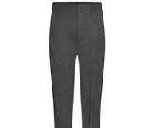 | £4.00
Pleated Skirt Navy (age 3/4,) – limited stock |  | 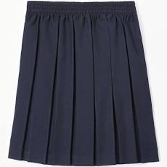 | £5.50
Fleece (age 3/4,5/6, 7/8 with logo) |  | 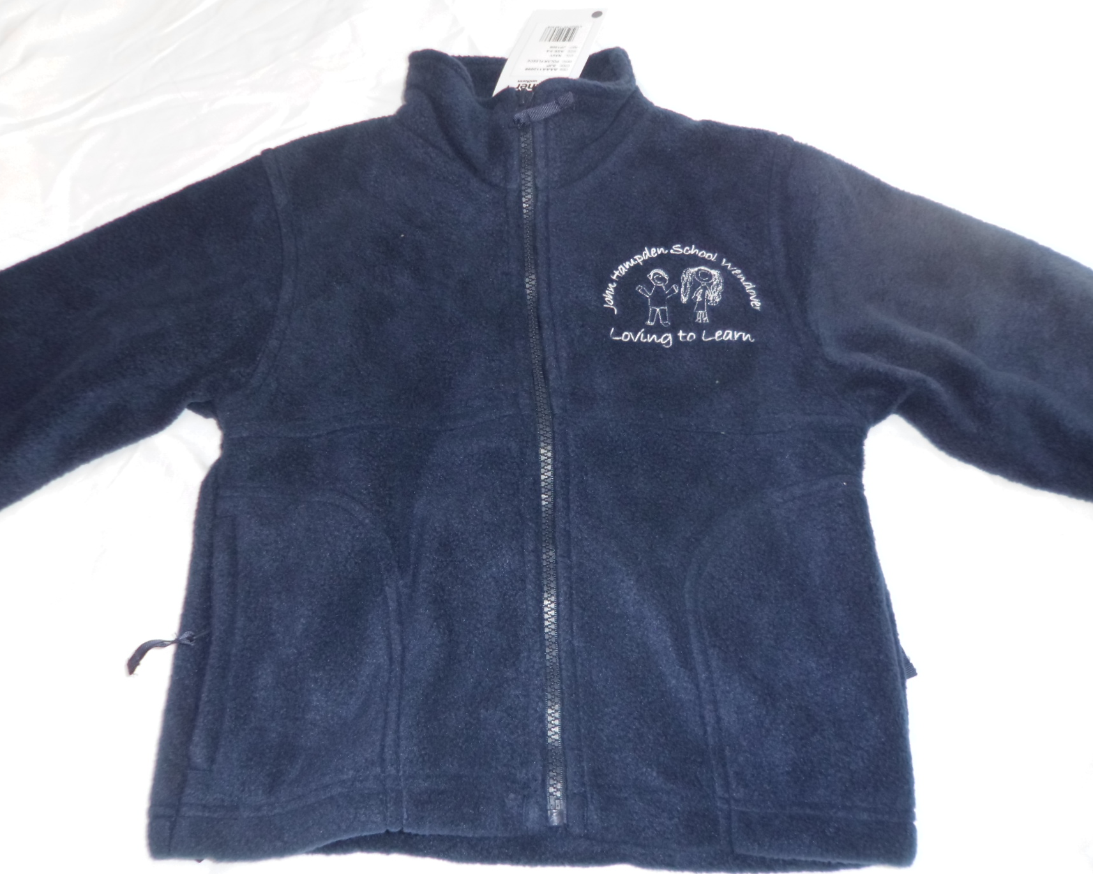 | £15.00
Navy Sweatshirt with logo (24”, 26”, 28”, 30”, 32”) |  | 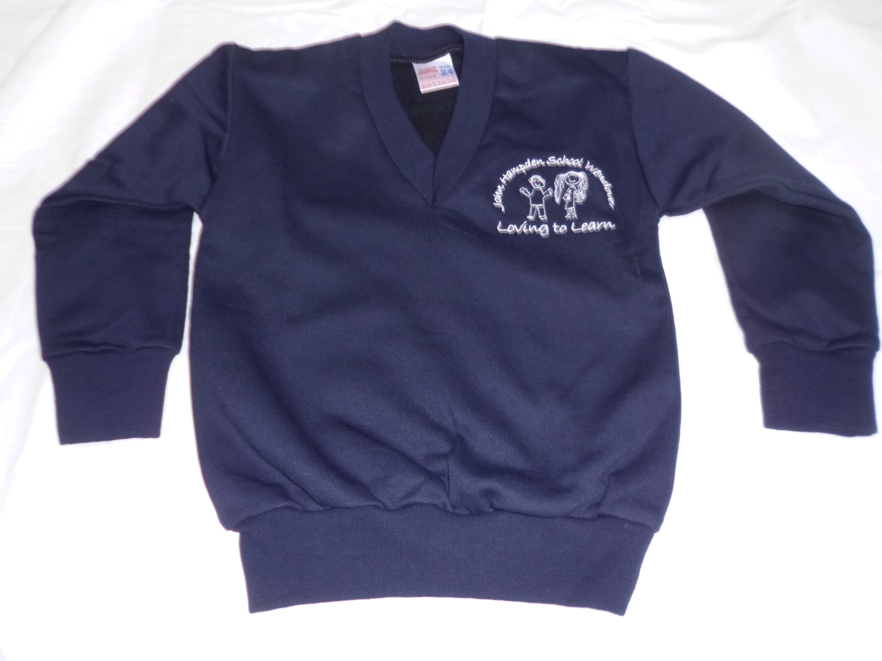 | £11.50
Navy Sweatshirt Cardigan with logo (24”, 26”, 28”, 30”) |  | 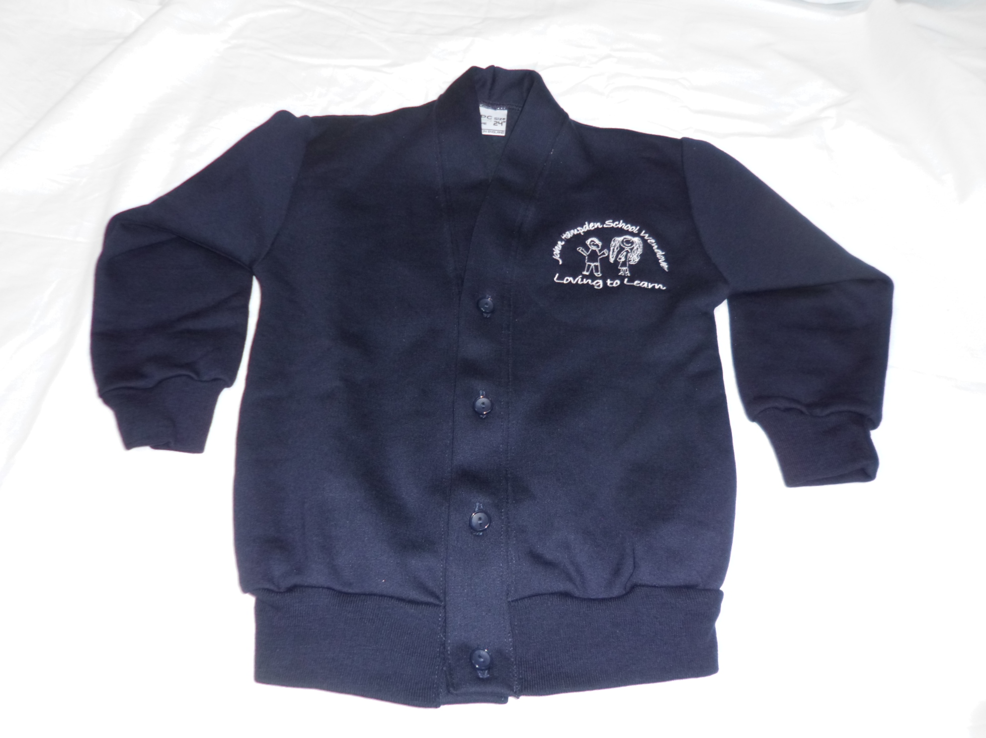 | £11.50
White polo shirt with logo (age 3/4, 5/6, 7/8, 9/10) |  | 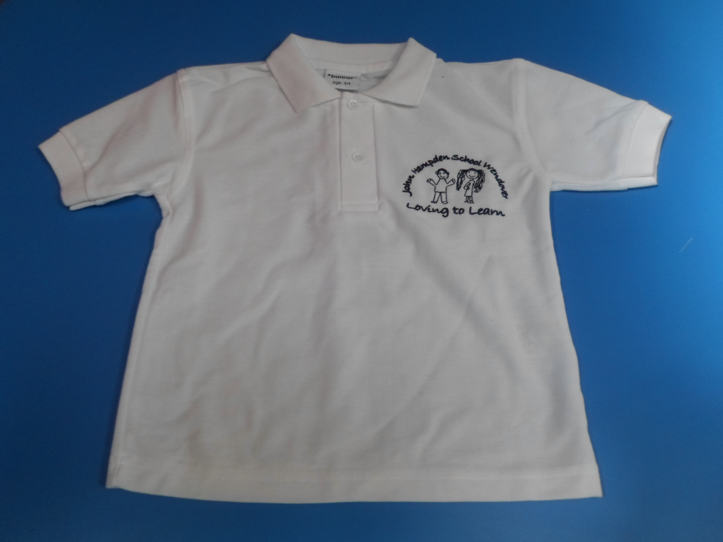 | £10.00
White PE t-shirt with logo (26”, 28”, 30”) |  | 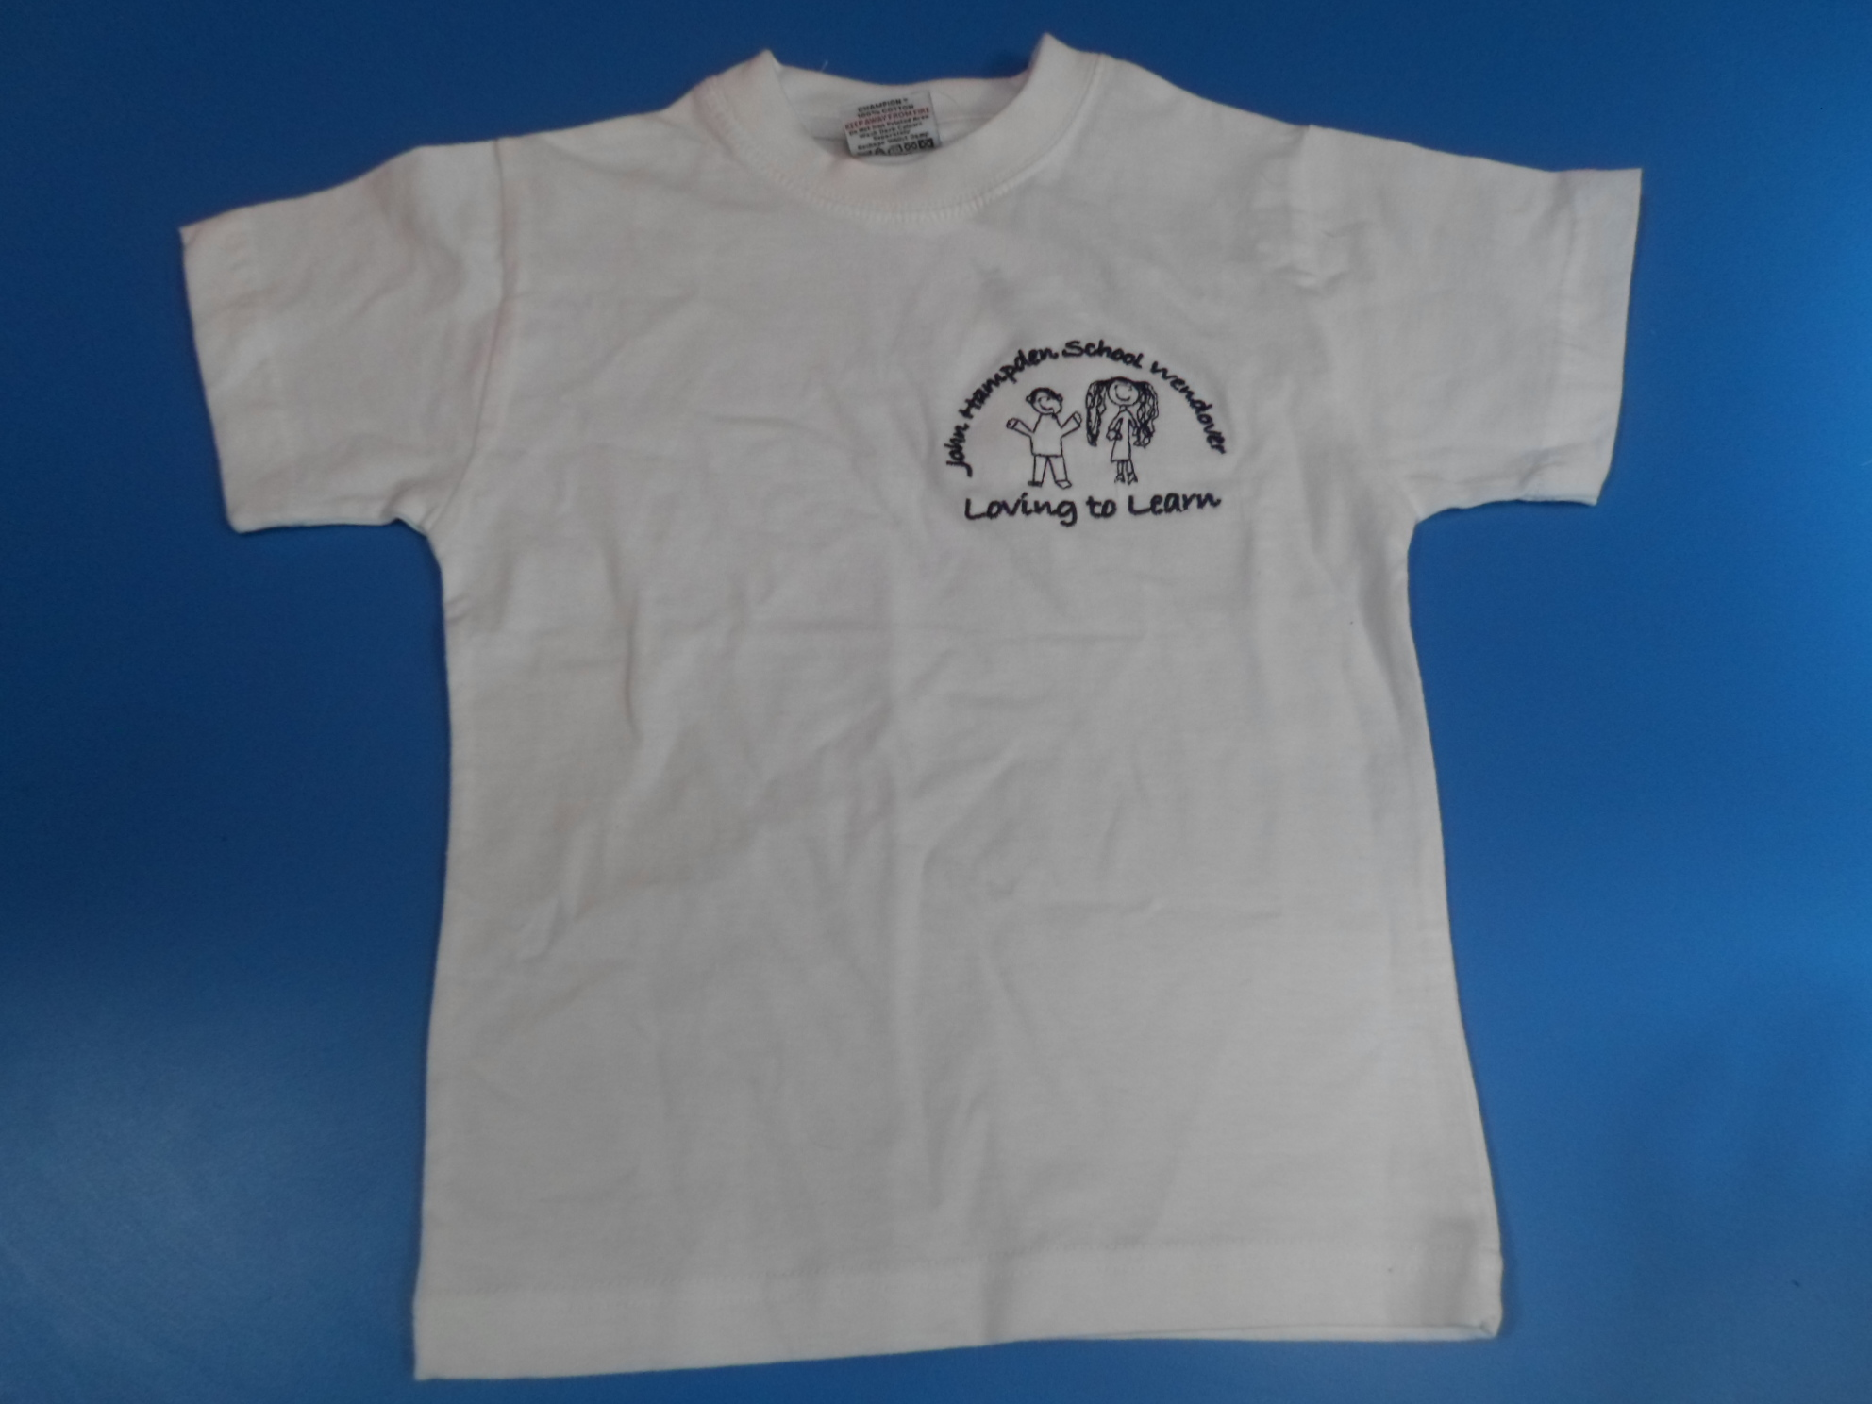 | £7.00
Navy PE shorts (22, 24”, 26”, 28”) |  | 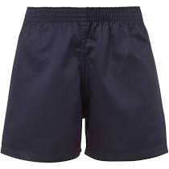 | £6.00
PE bag (black, red, maroon, purple, royal blue, navy, emerald green)  PLEASE STATE COLOUR |  | 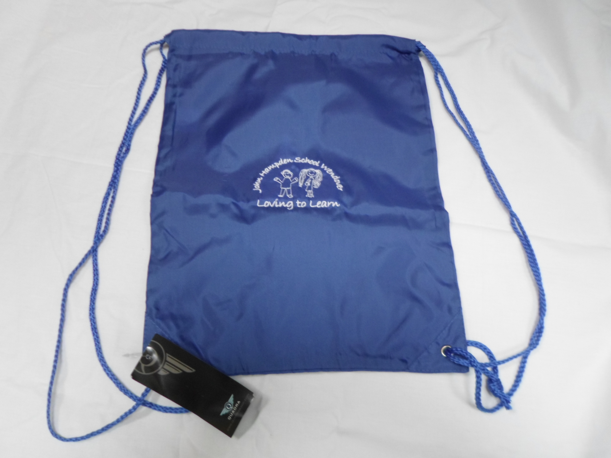 | £4.50
Waterproof reading folder/book carrier with logo (purple, navy, black, red, emerald green, royal blue, dark green)  PLEASE STATE COLOUR |  | 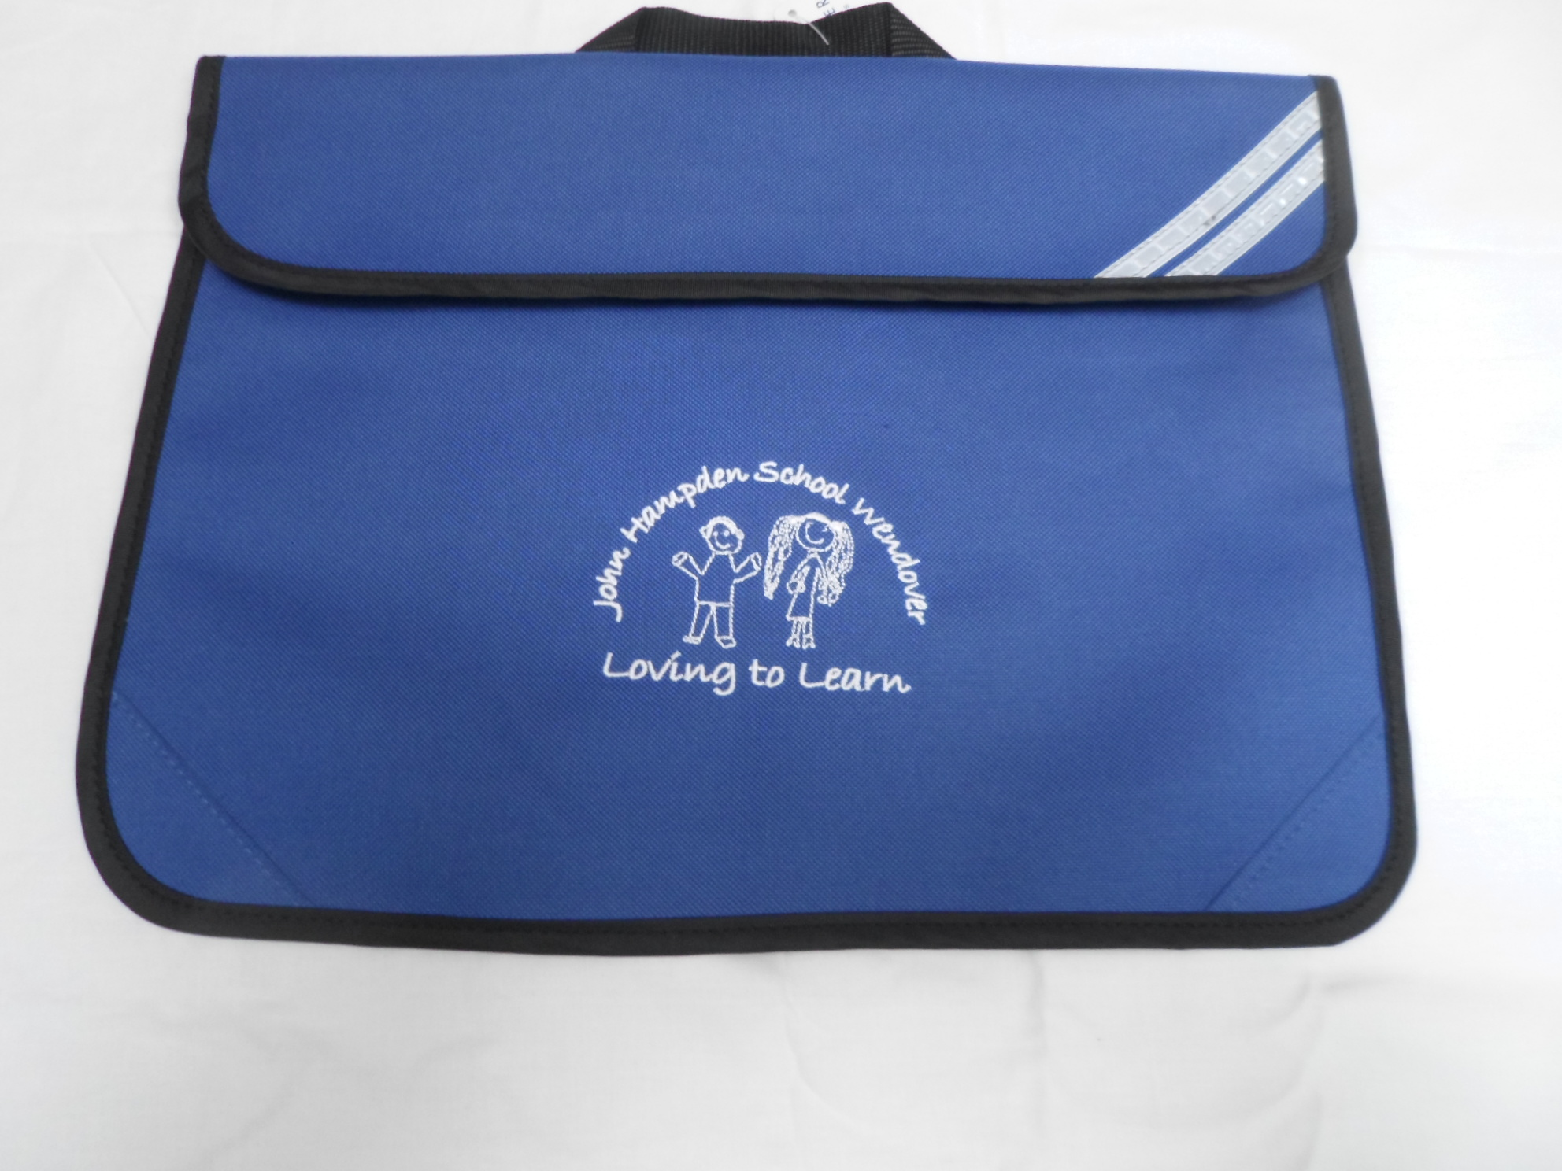 | £6.00
Woollen hat with logo (navy blue) – one size |  | 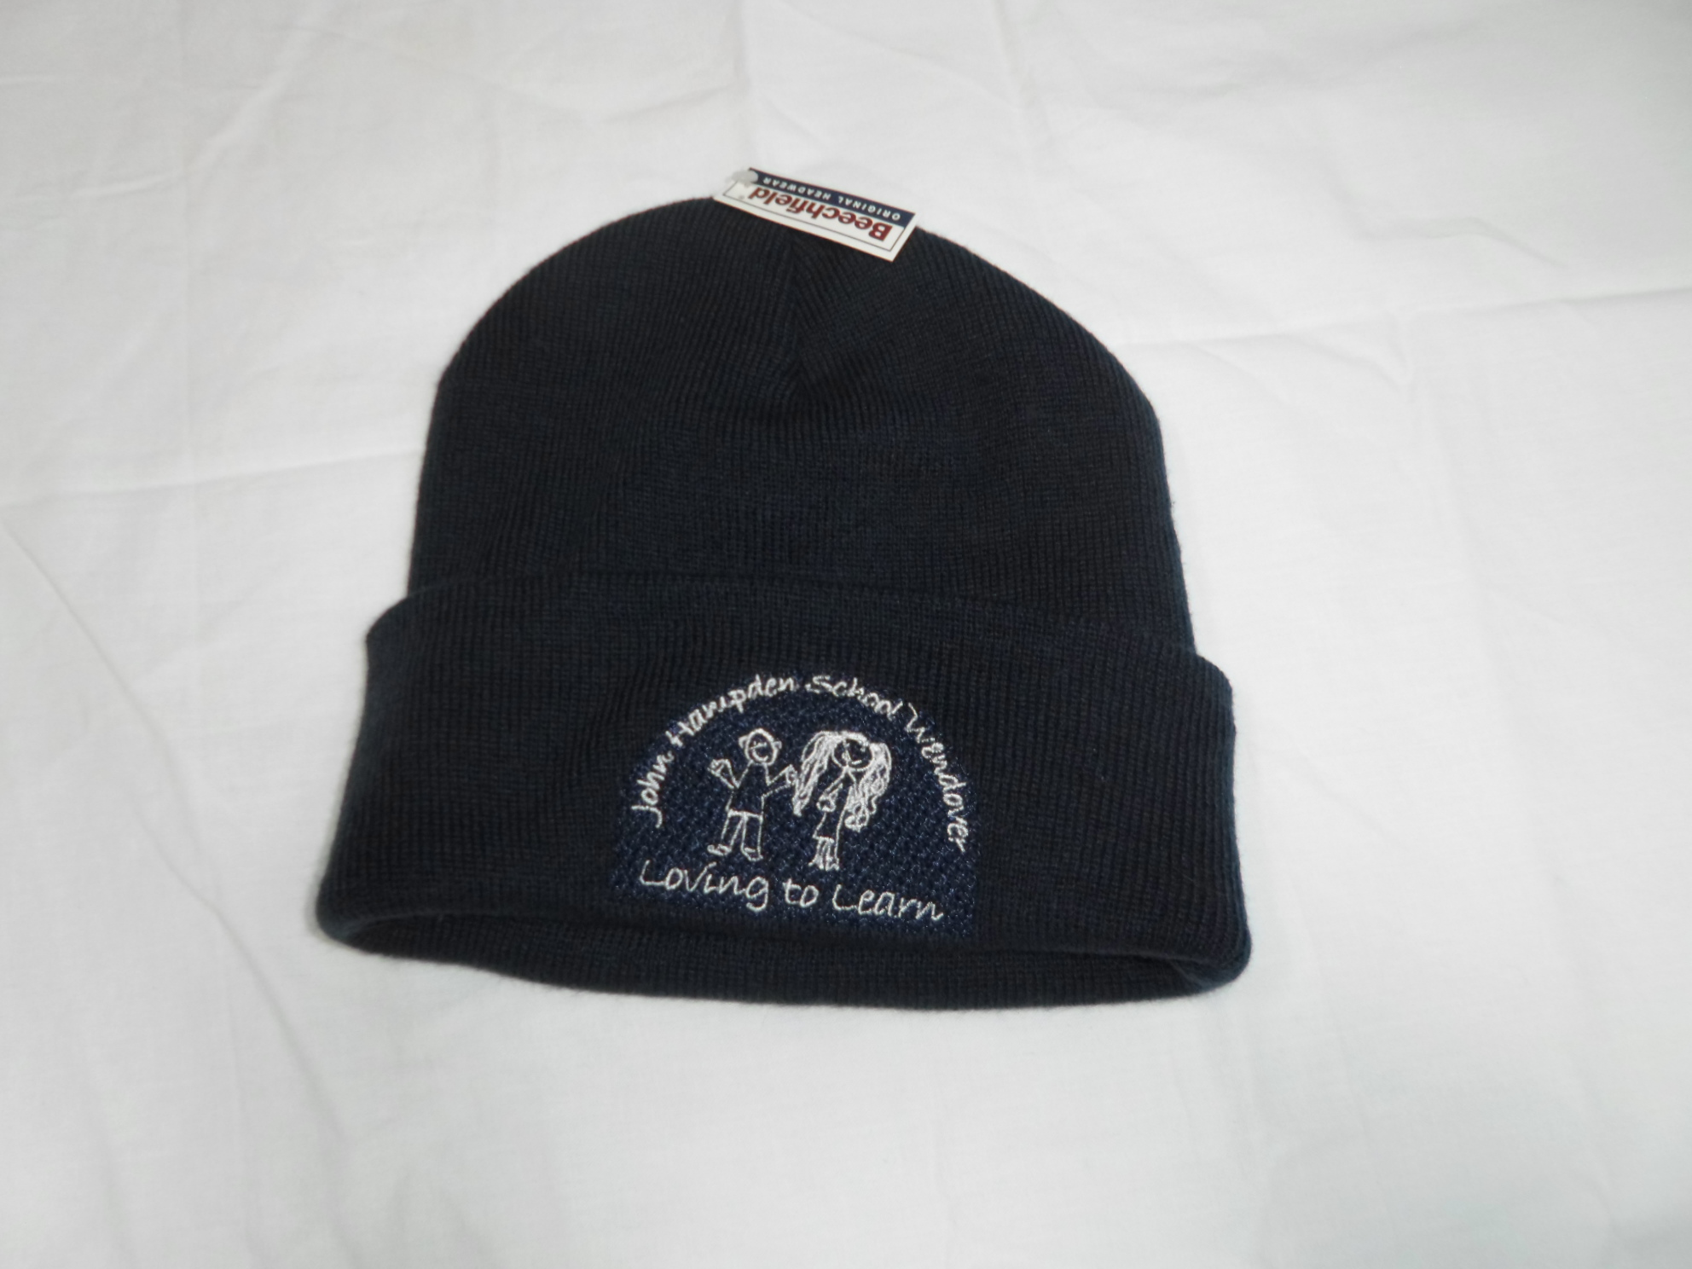 | £4.50
School money envelopes (book 40) |  | 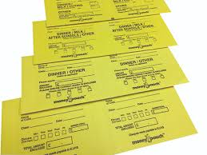 | £2.00
Nitcomb |  |  | £1.50
 | TOTAL |  |  |  |  |  | £

PLEASE MAKE CHEQUES PAYABLE TO “BUCKINGHAMSHIRE COUNCIL”

