Question Of The Week: Who is in my family? WB: 14.10.19
Activities based on questions asked by children….
We will be talking about our families. We will be talking about similarities and differences.  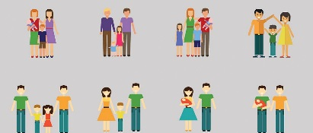 | As part of our topic, ‘Magical Me’, we will be talking about and drawing our families.  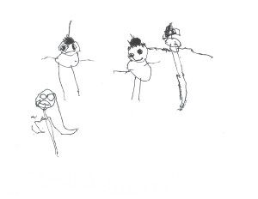 | We will be reading information books about different families.  We will read story books about ‘The Large Family’  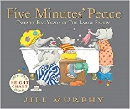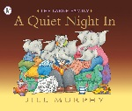
We will be playing listening games, rhyming games and orally blending games.  We will be introducing phonics;  i / n/m/d  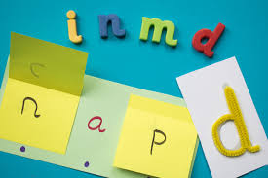  Look out for the 5 minute home sheets in the book bags to help with next week’s sounds. | We will be learning ‘All About Two’. We want the children to:  - understand that number two is the second  number used when counting a group of  objects  - recognise that the numeral refers to two  items and to be able to select 2 items from a  larger group  - understand ‘2’ as being ‘one more than one’  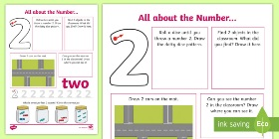 | We will be mark making and drawing patterns and shapes.  We will be continuing to practise writing letters from the curly caterpillar family.  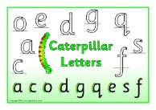 c
We will introduce the reflectors. They will help us to reflect on our learning and decide how we can make improvements.  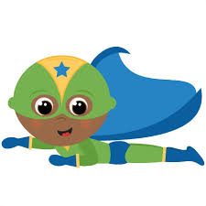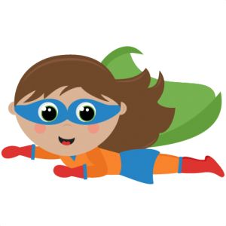 | PE is every Wednesday. | As part of our ‘Year of Kindness’ we will be meeting our Buddy Class this week.  