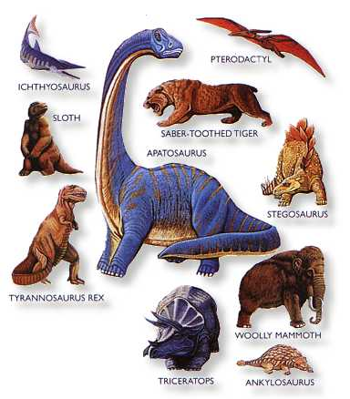

Foundation Stage
Topic Guide

Spring Term 1 –Explorer, Explorer
(Space)

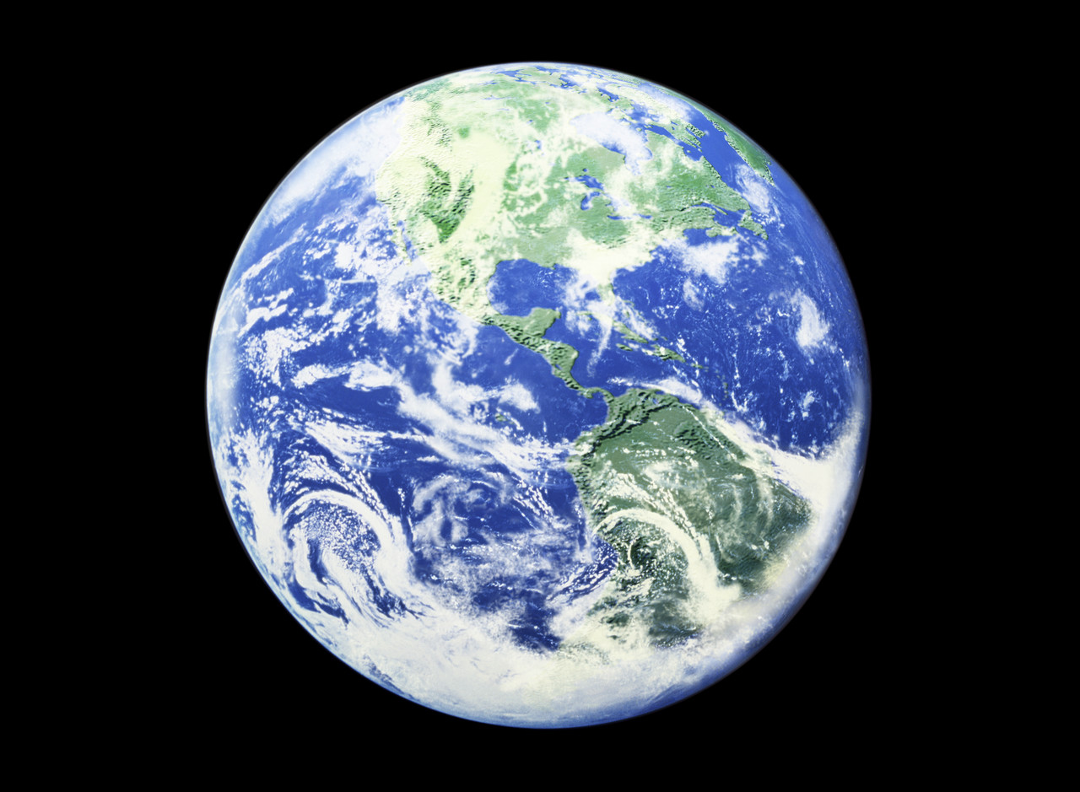

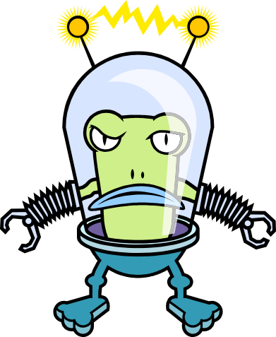

Our topic in Foundation Stage this term is “Explorer, Explorer”. We asked the children what they would like to learn about and they were interested in finding out more about Space and dinosaurs this half term.
In Space, the children will be learning about the planets that exist and about a variety of different Space topics. We are encouraging children to ask questions and respond to open ended ones. Here are a few examples we will be focusing on:

- What can we find beyond the sky?
- What is in Space? How do we get there?
- What would an alien/UFO look like?
- What planet do we live on? What makes Earth special?
- What would it be like to visit the moon?
- What would it be like to live on a different planet?
- What are stars? Which star is the most important for our planet?

Through art they will explore different mediums and textures to make a variety of Space pictures, models of planets, aliens and Space transport and will use ICT programmes to share their images of Space.
The children will be learning about music and movement and will be able to create their own dances based around Space.

We will be looking at a range of fiction, non-fiction and poetry books about Space in Literacy and topic sessions. In Mathematics we will be continuing to work on our recognition of numbers 0-20, finding one more and less than a given number and solving simple addition and subtraction problems. We will be exploring 3D shapes and using positional language.

Our key authors this half term are Jill Murphy and Claire Freedman so please look out for these authors at the library and share some of their books together at home.

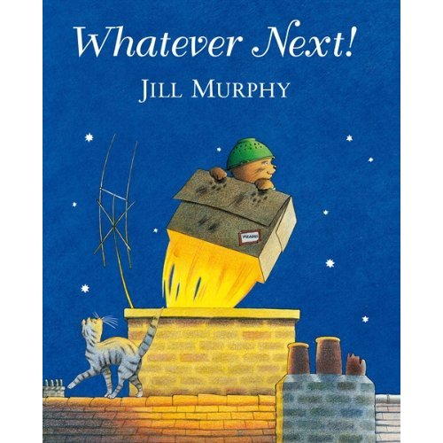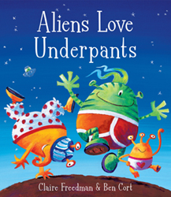

Places to Visit

Natural History Museum
http://www.nhm.ac.uk/

The Science Museum
http://www.sciencemuseum.org.uk/

Please let us know if you discover any other worthwhile places to visit!

Useful websites:

Google Earth

http://www.nhm.ac.uk/nature-online/space/index.html

www.nasa.gov/audience/forkids/kidsclub/flash/index.html

http://www.kidsites.com/sites-edu/space.htm

http://www.kidsastronomy.com/solar_system.htm

http://www.sciencekids.co.nz/

http://www.learninggamesforkids.com/space_games.html

http://www.educational-freeware.com/news/space-kids.aspx- 8 good websites about Space

Activities for Parents and Children to share at home

The activities listed below are suggestions for things you might like to try with your child at home. The activities will complement the work we are doing in class. It is not expected that everyone will try all of the activities.

- Make your own planet using lots of different materials.
- Can you learn all the planets names?
- Paint or draw a picture of an alien.
- Make a moon buggy out of playdough.
- Can you make up an alien story to tell?
- Research about Space and create a fact file about it to share.
- Use cardboard boxes to make a spacecraft
- Use wellies and silver paint to make moon boot prints
- Can you make different shadows using chalk and then map out in different parts of the day, where the sun has been?
- Make star cookies
- Make a space mobile
- Have a competition using foil to make different Space clothes
- Look out at night time and see what stars you can see
- Look at non-fiction books to look up facts about Space
- Count how many “moon jumps” you can do
- Find out how far the planets are away from the Earth and Sun
- Write a message to an alien/NASA

Moon Rock Recipe 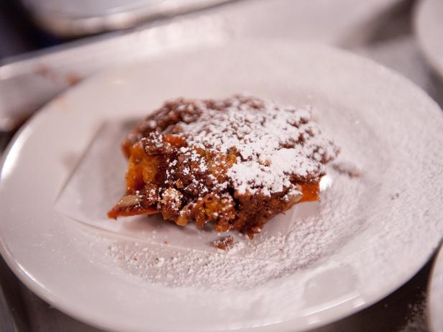

Ingredients:
- 250g milk chocolate
- 4 cups Kellogg's Coco Pops
- 200g mini white chocolate melts
- 2 cups mini marshmallows

Method:
Microwave the chocolate on high for 2 minutes stirring every 30 seconds until almost fully melted.
Stir until chocolate is smooth and fully melted. Allow to cool slightly.
Mix together the Kellogg's Coco Pop's, chocolate melts and marshmallows and add the melted chocolate. Be sure the chocolate is not too hot as it will melt the marshmallows.
Put a little vegetable or olive oil on your fingers and roll the mixture into teaspoon sized balls and place onto a tray lined with greaseproof paper or in paper patty cups.
Refrigerate until required.
* 900-watt microwave used. Timings may vary.

Science Q&A
Science Fair Ideas
Research
Videos
About Bob
Contact Bob
Privacy Policy

Make a balloon rocket 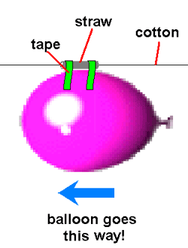
About Bob
Make a balloon rocket
You will need:
- 1 balloon (long ones work best!)
- 1 long piece of kite string (about 10-15 feet long)
- 1 plastic straw
- Tape

What to do:
- Tie one end of the string to a chair
- Put the other end of string through the straw
- Pull the string tight and tie it to another support in the room
- Blow up the balloon (but don’t tie it). Pinch the end of the balloon and tape the balloon to the straw
- NOW YOU ARE READY TO LAUNCH!
- Let the balloon go and watch the rocket.
Contact Bob
Privacy Policy

You will need:
- 1 balloon (long ones work best!)
- 1 long piece of kite string (about 10-15 feet long)
- 1 plastic straw
- Tape

What to do:
- Tie one end of the string to a chair
- Put the other end of string through the straw
- Pull the string tight and tie it to another support in the room
- Blow up the balloon (but don’t tie it). Pinch the end of the balloon and tape the balloon to the straw
- NOW YOU ARE READY TO LAUNCH!
- Let the balloon go and watch the rocket.

Useful Information
We hope you have had a happy festive holiday and are ready for our next learning adventures.
Please find some information below which we hope you will find useful.

Mrs Parkinson, Miss Head and Mrs Hope

Reading is taught throughout the week in our class and group lessons and specifically during Group Time Sessions. Additionally, individual reading books are changed on a Monday and a Thursday by the class teacher and TAs who may also listen to your child read.

Show and Tell will be starting soon. You should now have received a letter with further details and dates.
Letter formation resources can be found on the following websites:
http://www.twinkl.co.uk/resource/t-l-8447-letter-formation-alphabet-handwriting-sheet-lowercase.
http://www.sparklebox.co.uk/literacy/writing/letter-formation
Please remember that we add flicks across the top on the o, v, w

PE and Dance lessons will be on a Wednesday and the children will also continue Yoga lessons on a Tuesday on a rotation basis.
Please ensure your child has their PE kit at school ready for use and that all clothing is clearly named.
Winter PE kit; blue shorts, white T-shirt, plimsolls or trainers.
Children can also wear tracksuit tops and bottoms.

Children do PE every Wednesday with a Premier Sports Coach and Yoga on the following Tuesdays.
Tues 7th Jan  Honeybees Yoga | Tues 14th Jan  Caterpillars Yoga | Tues 21st Jan  Ladybirds  Yoga | Tues 28th Jan  Honeybees Yoga | Tues 4th Feb  Caterpillars Yoga | Tues 11th Feb  Ladybirds  Yoga
Paediatric First Aiders In Foundation Stage - Catherine Zucconi
Managing Medicines – Tracey Dale

Mallable/creative | Containing Gluten | Sesame | Egg
Play dough | Wheat ✓
Pasta | Wheat ✓
Rice | Wheat ✓
Cheerios | Wheat

The Foundation Stage Team

