Question of the Week – How do we know dinosaurs were real? WB: 03.02.20

We will be listening to each other talk about dinosaurs. Children can bring in a book, pictures, and dinosaurs – whatever they choose to. Please ensure that they are named.  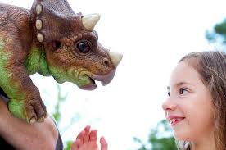 | We will be reading stories about dinosaurs.  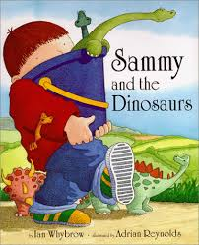  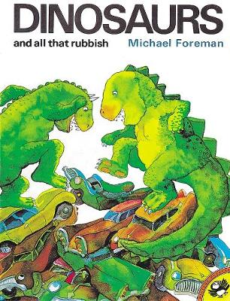 | We will be experimenting-predicting and testing how to make a volcanic eruption.  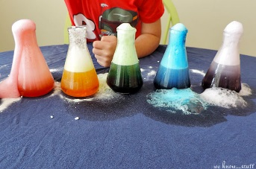
We will be looking at information books about dinosaurs and thinking about their similarities and differences.  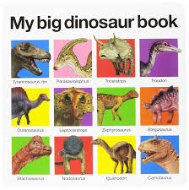 | We will be learning about number 9 and ways we can represent the number through actions, mark making and counting.  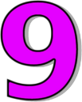 | In computing we will be using a paint programme to draw and write about dinosaurs.
We will be creating pictures of dinosaurs and using a variety of techniques to create a setting. We will be reflecting and seeing what we can do to make them even better.  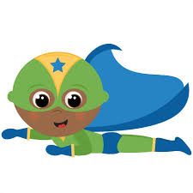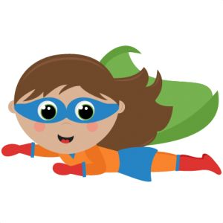 | We are talking about 2d and 3d shapes and the similarities and differences between them and measuring objects using different resources.  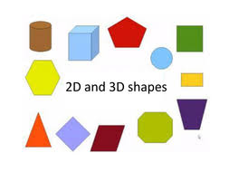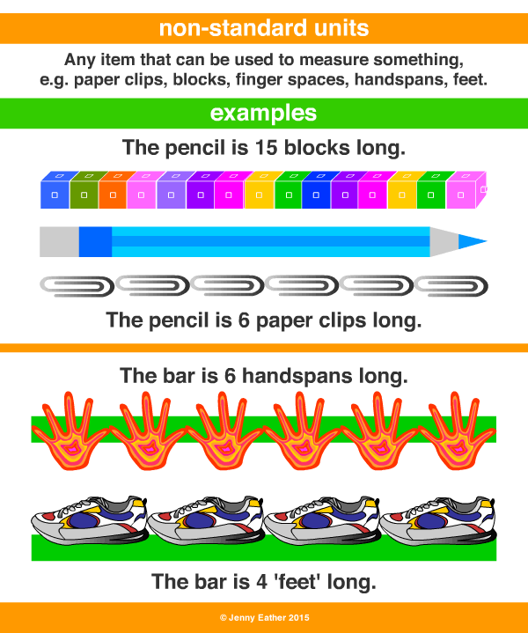 | We are writing for a range of purposes including story writing, writing a label for a model or instructions of how we made it.  