Question Of The Week: WB: 08.10.18
What part of our body does we use to explore our sense of smell and taste?
We will be reading Oliver’s Vegetables 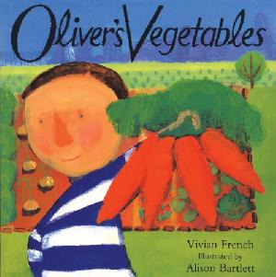 | We will be learning the story of Brown Bear,  Brown Bear What Can You See?  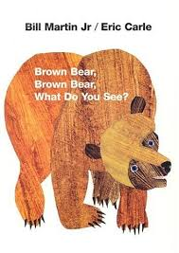 | We will be learning new sounds  i, m, n, d  and tricky words  to the  We will be continuing to play listening games including: Copy Me – copying a clapping sequence / Simon Says
We will be hunting in our foundation stage garden for sounds, numbers, signs of autumn and anything else that we think of……. | We are learning to play different maths games including Numicon Bingo and Lego Tower Race  Game.  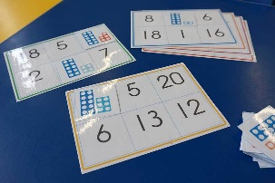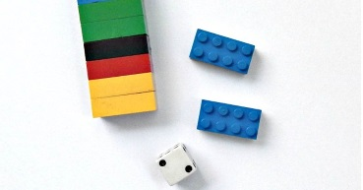 | We will continue to practise long ladder letters and curly caterpillar letters saying:  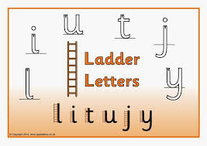start at the top, go down the long ladder and flick up at the end.  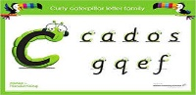 start at the caterpillars head, come back round under his tummy and curl up for his tail.
We will be continuing to discover the super learning powers that we all have, to reflect on our learning and think how we can make it better.  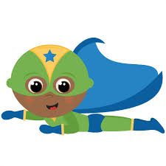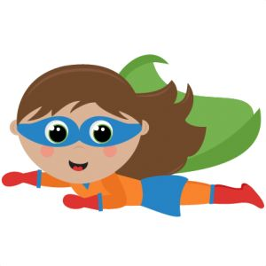 | We will be investigating different scents and smells. | Parent Notices:  Book changing is every Monday & Thursday, However children should have their reading book and spotty diary in school EVERYDAY.

