Questions This Week:
What animal am I? Where do I live? WB: 4.3.19
We will be writing clues about animals and trying to use adjectives to describe them.  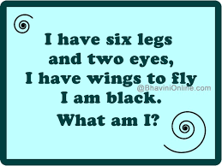 | On Tuesday Animal Educate are visiting us and we will have the opportunity to meet different animals.  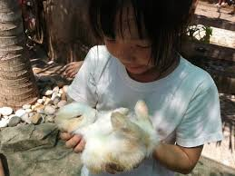 | We will be exploring the numbers 11 – 15  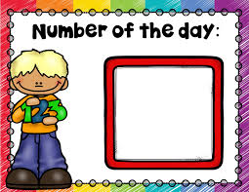
We will be exploring animal habitats and making animal homes outside.  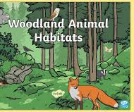 | On Friday it is World Book Day where we can come to school dressed as our favourite story characters.  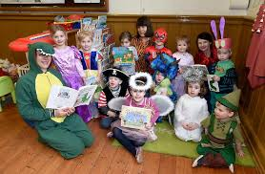 | Parents are invited into school at 2.45pm on Friday to share our learning.  