SAFETY WEEK – FOUNDATION STAGE

Monday 29th October | We will learn about safety around dogs in an assembly | We will have a safety talk from a police officer | We will meet Mrs West, the School Crossing Patroller, who will talk to us about Road Safety | We will learn how to cross the road safely with Junior Road Safety Officers from Wendover Junior School  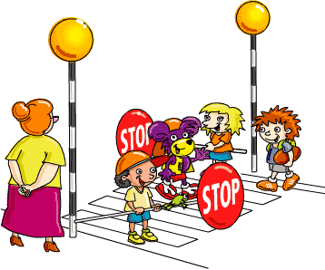 | At other times during the week, also linked to Safety Week, we will learn about:  - Safety through P4C  - Risk taking  - Resilience  - Anti-bullying  - Medicine safety  - Stranger danger  - Water safety will follow in early November
Tuesday 30th October | We will learn about e-safety with Mrs Shrimpton | We will learn about Fire Safety
Wednesday 31st October | We will have a multi-skills session with Premier Sport
Thursday 1st November | We will have an anti-bullying assembly with Mrs Barnes
Friday 2nd November | We will have a ‘Taking Care of Myself’ assembly | We will learn about Firework Safety

