SAFETY WEEK – YEAR TWO

Monday 29th October | We will have a multi-skills session with Premier Sport | We will learn about safety around dogs in an assembly | We will meet Mrs West, the School Crossing Patroller, who will talk to us about Road Safety | We will learn how to cross the road safely with Junior Road Safety Officers from Wendover Junior School  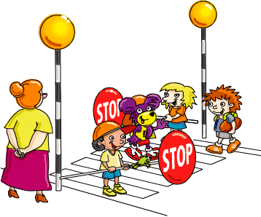 | We will learn about e-safety with Mrs Shrimpton | At other times during the week, also linked to Safety Week, we will learn about:  - How to enjoy Halloween safely  - Medicine safety  - Stranger Danger  - Risk and Danger  - What would happen if…  - Resilience  - Safety through P4C  - Anti-bullying  - Water safety will follow in early November  - Presentation - Monday 19th November by WJS Year 6 prefects about their visit to Hazard Alley  - WJS ambasadors to lead an anti-bullying assembly – date tbc
Tuesday 30th October | We will learn about Fire Safety  We will learn about Fire Safety | We will have a ‘Taking Care of Myself’ assembly | We will learn about bicycle safety
Wednesday 31st October | We will have a ‘Stay Safe’ assembly  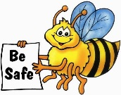
Thursday 1st November | We will have an anti-bullying assembly with Mrs Barnes
Friday 2nd November | We will learn about Firework Safety | We will have a safety talk from a police officer

