Question Of The Week: How can I keep myself healthy? WB:15.10.18

We will be looking at information books about keeping healthy. | We will be reading stories about keeping healthy.  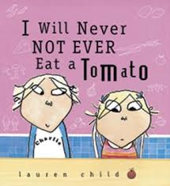 | Every day we will be running for 5 minutes.
We will meet a paramedic who will talk to us. We will be able to ask lots of questions. | We will be making fruit kebabs. | We will meet a doctor who will talk to us about keeping well.
Early morning fitness session with Jodie Digby – all parents and children welcome – Tuesday 16th October, 8.30- 8.45 am in the main playground. | Please come to school every day in clothes that are suitable for exercise. | We will be talking about how to keep our teeth healthy and clean.  