Question Of The Week: How can I keep myself safe? WB:29.10.18

We will be looking at information books about keeping safe.  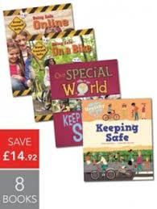 | We will be reading Burglar Bill  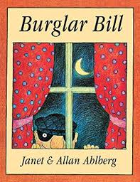 | Everyday Mrs Shrimpton will be talking to us about e-safety.  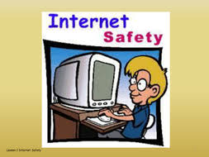
Mrs West our Crossing Patroller will talk to us about road safety.  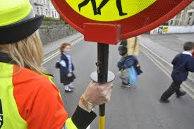 | We will be learning about safety around dogs.  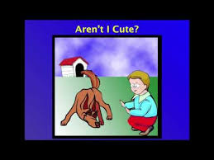 | We will meet a police officer and have the opportunity to ask questions.  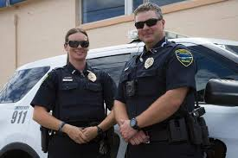
We will be learning about fire safety and drawing fire engines.  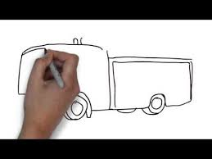 | Mrs Barnes and Mrs Parkinson will talk to us about how we can take care of ourselves. | We will be talking about how to stay safe if we go to a firework display.

