Question Of The Week: How are colours used in celebrations? WB:26.11.18

We will be using our knowledge of mixing paint to create pictures.  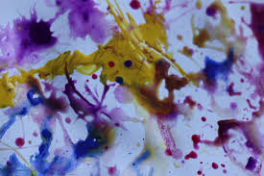 |  | We will be writing letter shapes, words, captions and sentences.  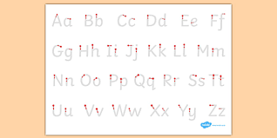
We will be going on the stage to rehearse our Nativity.  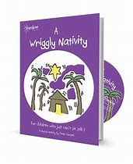 | We will be continuing to find one more and 1 less.  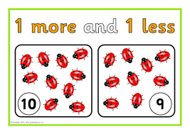 | We will be thinking how colours are used in celebrations.  