Welcome to
The Early Years
2021-2022
Updated Induction Information

Meet the Early Years Team
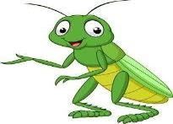

Mrs Taylor Mrs Wheeler
MrsKearney Mrs Khan

The Nursery Day …

- For the first half term, there is no set timetable –the children are learning to learn in the indoor and outdoor environment and getting to know their new teachers, teaching assistants and class friends.
- The children spend their time with their class teacher and teaching assistant. Children learn through a mixture of play, child initiated exploration and adult led teaching.

Uniform
- Please ensure that names are labelled in EVERYTHING!!! (including lunch boxes)
- Please send coats in EVERY DAY.
- Please send children in with sunhats on warm days.
- Sensible shoes and no jewellery.
- Children are active for most of the day.

Independence

Please continue to encourage your children to independently practise;

- Going to the toilet and wiping their bottom independently

- Getting dressed and undressed; jumpers & cardigans, shirt and coat buttons & zips, shoes and socks.

- Recognising their own name and initial sound.

- Pouring water and drinking from an open top

Behaviour Expectations…
At John Hampden School, we encourage children to follow the school’s behaviour expectations to help keep everybody happy and safe.

School Values and British

Values
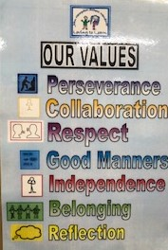

Expectations, Incentives and
Recognition

We are always looking for ways to recognise and praise children for their positive attitudes, fabulous learning and for following The John Hampden behaviour expectations or demonstrating our school values. This may be in the form of :
- stickers awarded by Teachers, Teaching Assistants and support staff to children

- children’s learning being displayed on the class ‘Loving To Learn’ board
- Children’s names being displayed on the class ‘Recognition board’ for recognition of positive behaviours

- ‘M.O.V.E Time’ (Mastering Our Values and Expectations) weekly activities that help the children to develop and enrich their understanding of the behaviour expectations and the school values.

- Positive role modelling including ‘Wonderful Walking’, ‘Super Sitting,’ ‘Legendary Lining up.’

Golden Stars.

Children’s learning is displayed on the ‘Loving To Learn Board’ or on another display board. A gold star always accompanies the ‘learning’ with an explanation. The star is then transferred into individual learning journals.
WOW Moments

- ‘WOW’ moments -

Your child has brought home a sheet of blank wow moments. These are for you to fill in with anything your child has done at home that has made you say
‘ WOW’ e.g. trying a new food, sleeping in their own bed, riding their bike for the first time…..
- WOW moments are displayed and transferred into Learning Journals along with Kindness cups that have been awarded for showing acts of kindness.

- The children will also be awarded the Scroll of Honour for being spotted doing something special. Every Friday the certificates will be sent home along with a badge to wear for the following week. Please ensure that the badge is returned on the following Thursday so that they can be collected and given out again.

Communication…
Please ensure that your child brings in their book bag every day.

Home / school diary
This is a useful communication tool. Please sign when your child has read their book and at the end of every week. Please also encourage your child to draw a happy, sad or unsure face in the relevant box each day. This gives us an indication of how they are feeling about being in school.

Please let us know if there is a message for us as we only check diaries on Monday & Friday otherwise.

Communication Sheet
A brief preview of what the children will be learning about the following week will be available on the Class Page on the school website.

Termly Themes
This half term our theme is “This is Me.” We will be finding out about one another, our families and the things we like/dislike. We will create a special “This is Me” display sharing our interests.

Going home
Please let us know if your child is being collected by someone other than you or your named person/people.

Healthy Eating…

Healthy Eating Policy
We encourage healthy eating in school and do not allow children to eat solid chocolate bars as part of their packed lunch.

‘No Nuts’ Policy

There are several children who have an allergy to nuts within the school, so please do not put nut products / ingredients in your child’s lunchbox. Thank you

Allergens

Allergens
We will inform you of the allergens that will be in resources or ingredients. Playdough is a resource we use continually.
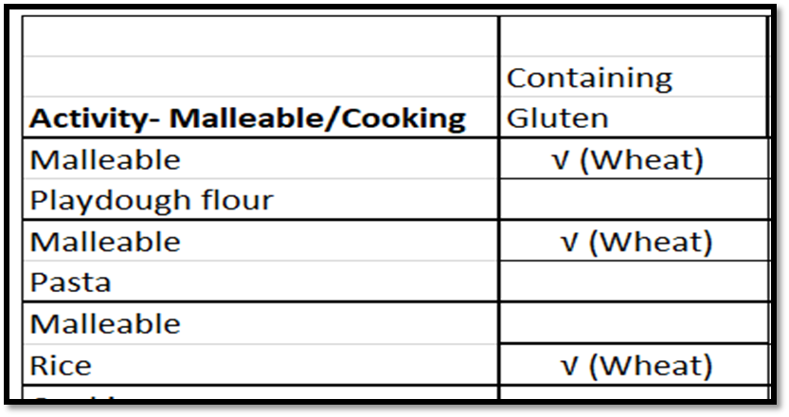

Snack and Lunchtimes

- Milk, water and fruit is available at every morning snack time
- Water is always available throughout the day from the Hydration Station
- Packed lunch only
- The children will bring home what they haven’t eaten
- We encourage them to drink at least half of their water bottle, if not more.

Voluntary Contributions and Wish List

Voluntary Contributions
To help us continue to provide exciting and stimulating activities and experiences for the children, we ask for a small voluntary contribution towards some experiences and resources. A letter detailing contribution areas is sent out termly.

Wish List
We may sometimes ask for donations of items that you may have at home. E.g. left-over Christmas cards/wrapping paper, straws, tissues, cups. We also always welcome any items you have at home that you do not use – ranging from books, to unwanted telephones, to pallets, cable reels and teapots. Due to the current circumstances, we will leave items for a period of time before we clean them.

Resources That Have Been Donated In Recent Years
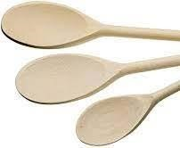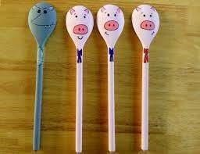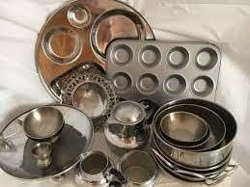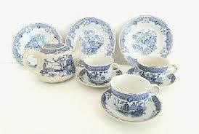

First Aid…

First Aid
We have qualified first aiders.

Head bumps
Any child who has a head bump during the day will bring home a ‘Head Bump’ note and have a ‘Head Bump’ sticker on their jumper.

A Polite Request...

Toys
Due to the circumstances we face at this time, please do not send your child into school with toys, key rings or other valuable or sentimental items unless it is for a specific ‘Show and Tell’ session, as advised by the class teacher.

Phonics
The ability to read has truly become a necessity to survive and thrive in today’s society. Phonics is the most successful way to teach reading. There are 3 main stages that we teach in the Autumn term:
- Speaking and Listening Skills
- Sound Discrimination
- Rhythm and Rhyme
- Oral Blending and Sound Recognition

Phase One Phonics

- This phase of teaching is essential in teaching the listening and discrimination of sounds that allows children to go on to Oral Blending
- We teach this through activities like:
- Music and movement
- Sound Safari
- Rhyming Stories
- The Poetry Basket

Sound recognition
We teach the children the sound that the letter makes, not the letter name. At this stage we do not even say the name of the letter as that is confusing.
We need to be careful that we teach the correct pronunciation – no schwaring!!!

Tricky Words

There are, of course, words in the English language that you cannot sound out. These are called tricky words and need to be learnt by memory. Before words are introduced, children need to develop the skill of recognising logos.
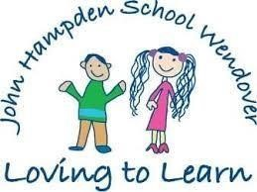

Phonics
Soon, we will send home a phonics activity sheet every
Friday. This will enable you to see exactly what your child has learnt in the week, and what they will be learning the next week.
Please can we ask for you to spend a short time practising oral blending, sound recognition, blending or tricky word reading.
Little and often is most helpful .

Writing

- To be able to write successfully, children need to develop gross and fine motor
skills, hand-eye co-ordination and pencil grasp development.
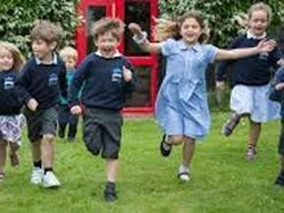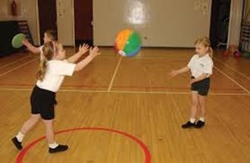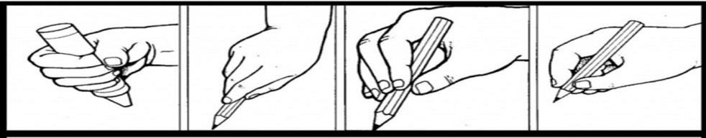

Drawing

- It is important to give drawing the same recognition that we give writing.
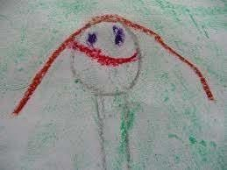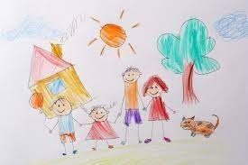

Pre-writing Shapes

• We teach the children to draw particular shapes so that they will be able to form letter shapes.
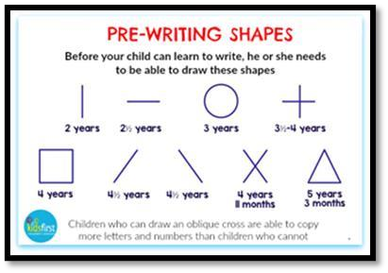

Handwriting Families

We then teach children to form letters through handwriting families.
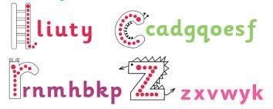

Mark Making

As children are learning all of these new skills, it is important that they have the freedom to make marks and explore putting pen/pencil/chalk/ paint to paper.
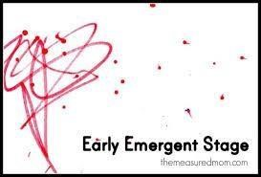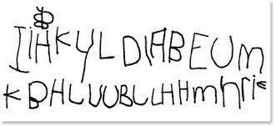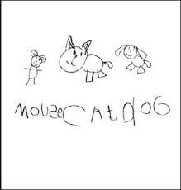

What can you do to help your child’s mathematical development?

Subitising- to identify the number of things in a set simply by quickly looking at them—not by counting them one by one.

This is perhaps one of the most important skills to develop before counting. It is crucial in giving children true fluency and understanding of calculation later on in their mathematical journey.

Subitising

We need to give children opportunities to see and label whole amounts without counting.
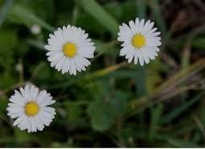

What else can you do to help your child’s mathematical development?

- Number recognition up to 10 (out of order)
- Record numbers in different ways i.e marks, pictures, tallies….
- Shapes, colours and patterns
- Weighing and measuring.
- Maths in the ‘environment’

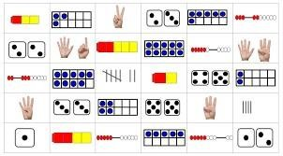

Learning Journals

Children in The Early Years have their own ‘Learning Journals’ where we record some of the ways in which your child is travelling along a learning journey which is unique and special to them. The aim is to:
- Celebrate achievements
- Monitor the skills that the children are developing
- Show progression
- Capture how children learn as well as display experiences of children who are active thinkers
- Record children’s viewpoints
- Highlight discoveries children make
- Illustrate how learning in underpinned by supporting and evaluating children’s sense of wellbeing and engagement in their learning.

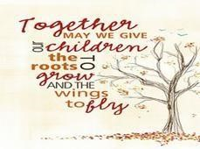
Partnership with Parents

To help your child fulfil their potential in The Early Years, it is vitally important that we work together to provide a consistent and positive approach to your child’s learning, both at school and at home.
We operate an open door policy and are always happy to talk to you about any concerns or issues you may have. Due to the current COVID-19 situation, indoor meetings are restricted but we will endeavour to either meet with you outside or have a telephone conversation at an agreed time.

Settling in Meeting -
You will be offered the chance to meet with your child’s class teachers during the Autumn Term to find out how well your child has settled in. More details will be provided shortly.

And Finally. . .
We look forward to working with you and your child throughout the school year.
The Early Years Team ☺
