HEALTH WEEK – YEAR ONE

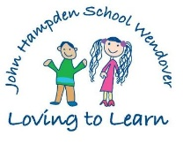

Monday 16th October | We will use ‘Purple Mash’ on the computers to complete activities linked to Health Week. | We will work with A-Life to complete some Healthy Eating activities  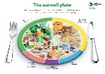 |  | At other times during the week, also linked to Health Week, we will complete:  - Relaxation techniques  - Circle Times  - P4C sessions  - Target setting  - Mindfulness activities  - Healthy Eating activities  - Problem solving activities
Tuesday 17th October | We will complete a P.E. session with a Premier Sport Coach. | We will have a Fun Fitness session with A-Life | We will meet Doctor Evans who will teach us how to keep well.
Wednesday 18th October | We will complete a yoga session with Mrs Grimsdell | We will learn about the 3 C’s -  Courage, Curiosity and Creativity with Everyball
Thursday 19th October | We will have a ‘Passport to Fitness, walk or scoot to School’ Assembly with time for questions.  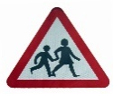 | We will complete a Zumba Workout with Mrs Nelson.
Friday 20th October | We will make a Fruit Smoothie with Mrs Spencer  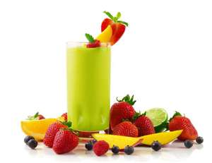 | We will learn about Dental Health with Mrs Brooman

