Questions This Week: WB:21.1.19
What would it be like to live on a different planet? What would an alien look like?
We will be reading stories about aliens.

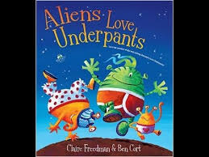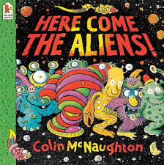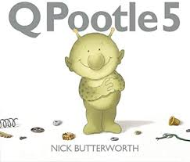
We will be learning about time - measuring short periods of time, using everyday language related to time and talking about time to compare and solve problems.  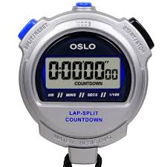 | We will be learning about money -  using everyday language relating to money, talking about money to compare and solve problems.  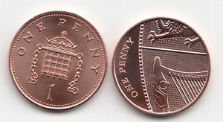 | We will be learning about shape –  using 2D and 3D shape names, describing shapes, selecting shapes and using mathematical language.  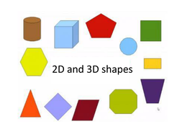
We will be making aliens. First, we will plan what we would like to do. When we have made our aliens we will reflect and see if there are any changes that we would like to make them even better. | 