WB: 6.5.19
We will be writing about our walk around Wendover.  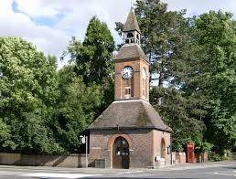 | We will be reading The Three Pigs and talking about the characters.  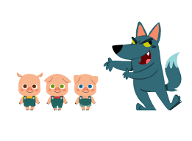 | We will be counting in 2’s 5’s and 10’s forwards and backwards.  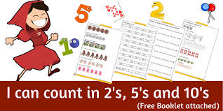
We will be finding out how houses were different in the past.  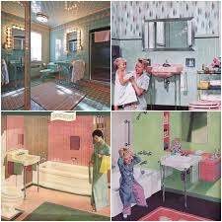 | We will be exploring numicon using the part part whole model. | On Monday we will all be enjoying our Bank Holiday Monday.  Fingers crossed that the sun will shine!

