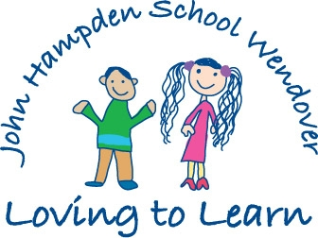

Dear new member of Crickets class

You are invited to two visits to your new Early Years Nursery Class

at The John Hampden School Wendover on :

Tuesday 6th July and Tuesday 13th July

from 10.00 – 11.00 am on both occasions.

Each time you will have the chance to meet your new

teachers and to see inside the Nursery.

We hope you will be able to come and meet all the other children who will be joining the Nursery in September.

We are really looking forward to seeing you.

There will be a meeting for parents of children joining the Nursery on Monday 21st June at 6.00pm. This meeting will be held in the school hall.