Question of the Week – What animal am I? Where do I live? WB: 02.03.20

We will be having a visit from ‘Animal Educate’ and will get the opportunity to learn about different small animals, mini beasts and reptiles.  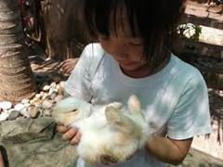 | We will be learning about height, length and weight and comparing objects using mathematical language.  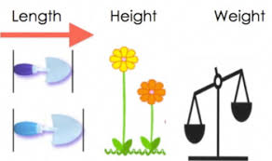 | We will be writing instructions about how to draw different animals.  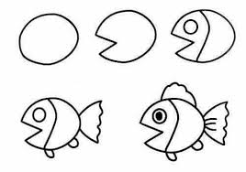
We will be exploring animal habitats and making animal homes outside.  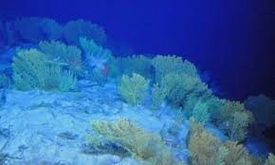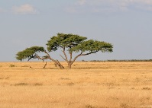 | We will be reading and re-telling stories, poems and songs about animals.  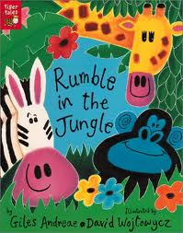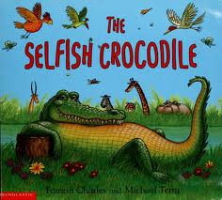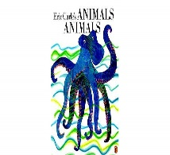 | We are continuing with a daily focus of learning to read and write our High Frequency Words. Please keep practising at home using the Phonics sheets.  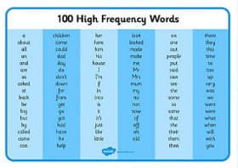
As ‘Masters of Ideas’ we will be thinking of ideas and working with others to grow ideas.  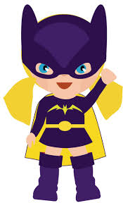 | As ‘Dynamo Planners’ we will be thinking of our own ideas and challenging ourselves to plan what we want to do and what we will need. | World Book Day Friday 6th March  Please come dressed as your favourite book character.  