Year 2
SpringTerm – 1

The Great Fire of London
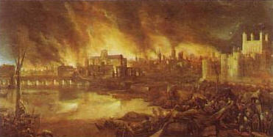

Useful Information
Dear Parents,
The children are continuing to come into class by themselves and they are following the routines in Year Two independently.
Following the success of our previous ‘Thinking Day’, we will be holding another one during this half term as part of a special Discovery Week starting on 10th February. As well as a focus on P4C during that week, the children will also be challenging themselves while solving problems and carrying out investigations in Maths & Science. The whole week will have a strong emphasis on Growth Mindsets.
As many of you are keen to know what your children will be learning about during this half term, we have attached an outline of the areas we will be covering. Please note that we are continuing to use a topic based approach to teaching and learning.
Topic
The topic for this first half term is “The Great Fire of London”, with a strong emphasis on History. We will look at the events leading up to and following the fire. An exciting box had been ‘found’ by the builders and the children were excited to open it. Looking at the items found in the box, the children decided they belonged to Samuel Pepys. Following this discovery, we are focusing on the diary of Samuel Pepys and looking at other sources of information recorded at the time. We will be using ICT to help research the topic leading to a greater understanding of this period in history. Art will also be covered using a variety of mediums to create some ‘Fire of London’ collage houses and pictures. Our science topic this half term will be based on learning about materials and their properties.

English
We will learn the skills required to write a recount of the The Great Fire of London. These will include using; time connectives, writing in the past tense, verbs, adverbs and expanded noun phrases. We shall continue to focus on presentation of writing and punctuation as well as grammar. The Talk for Writing approach to assist the children with memorising what they want to write, will also be continued. Also, we intend to teach and learn some poetry and a special rap linked to the topic.

Maths
We will focus on subtraction during this half term. We shall teach the children about fact families, inverse operations as well as different ways of partitioning while taking away, beyond the use of a hundred square. We will also solve a range of word problems to further improve their understanding of reasoning. There will be a continued focus on learning multiples of two, three, five and ten as well as mental recall of number bonds to 20.
They will continue to practise number writing in word form, every week.
The children will also complete practical activities and problem solving tasks linked to Time. Please continue to provide a range of practical activities to support your child with their numeracy work e.g. cooking (reading scales), shopping, board games and looking at odd and even house numbers etc. Continual practise of number bonds to 10 and then to 20 in order that they might have instant recall would also prove beneficial. Please do speak to the class teacher if you have any questions.

Spellings
The spelling routine continues in the same way, new ones will continue to be sent home weekly and tested each Friday. It is vitally important that their books are returned on a Friday so that your child may write their latest spellings in. The spellings will follow a pattern of sounds which are linked to our daily taught phonic sessions. Also, we ask that the children continue to practise spelling the High Frequency and Tricky Words in their reading diaries. We advise a ‘little and often’ approach to learning them, throughout the week. We are expecting these words to be spelt correctly in any writing they do.

Reading
Children will be heard by the teacher or teaching assistant each week. They will also be heard read during weekly Guided Reading sessions. Please try and hear your child read for at least 10 minutes every day, discussing their books with them and also asking appropriate questions about the text to help them to develop comprehension skills.

Phonics
This will continue to be taught daily in Year Two and will be referred to throughout all lessons. During these sessions, children are taught to blend to read and to segment to spell. Please continue to practise the spelling patterns in Phases 2-5, the school website contains all spelling patterns taught. We have moved on to teaching Phase 6 which focuses on grammar & punctuation, this half term learning will include; suffixes, questions, commands, statements & homophones.
Tricky & High Frequency Words
Each week during Phonics & English lessons, the classes will continue to practise reading & spelling High Frequency and Tricky words including the Year Two Common Exception Words.

Home/School Diary
We would like you to continue to complete the Home/School Diary on a daily basis. Please ensure you initial the book when you have heard your child read to enable us to change completed books on Tuesdays and Fridays. The children will not be allowed to change their books unless the diary is signed. Please also check that your child fills in the “smiley faces” as this gives us a strong indication of how they feel about their time in school and we can discuss any issues/concerns they might have. Teachers will also sign the diaries. If you have written any notes for us in the communication box please ensure your child shows them to the class teacher/teaching assistant on entry.

Homework
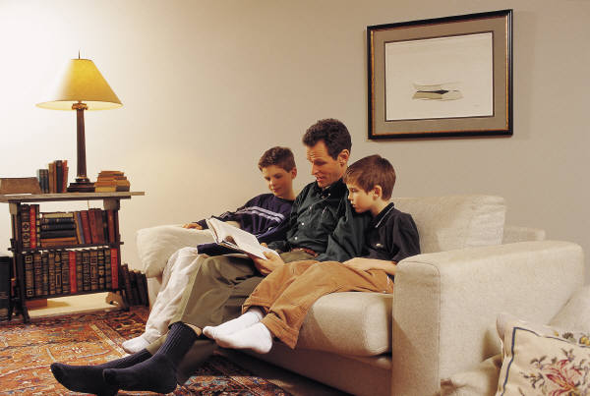
In Year Two, we will continue to issue homework on a fortnightly basis except before a holiday. The timing enables children to work on and extend the homework as appropriate to their needs e.g. little and often over the fortnight or one or two longer sessions. We would now expect at least two pages of homework to be completed each fortnight. We encourage the children to use a range of approaches that might include research on the computer, photographs, diagrams and illustrations. Homework books are given out on a Thursday and we expect it to be completed by the second Tuesday. Please ensure your child writes in pencil and they present their work carefully. Please also make sure that the spelling of high frequency and tricky words are correct. If for any reason your child is unable to complete the homework set, do come and talk to the teacher or teaching assistant.


P.E.
P.E. lessons currently take place on Wednesdays and Thursdays, but may also take place at other times during the week. Please ensure that your child has an appropriate P.E. kit for sessions inside and outside. Also, please check regularly that their plimsolls or trainers fit appropriately. Do ensure that your child has an appropriate PE kit for sessions inside and outside – ALL NAMED, this should include jogging bottoms or leggings and socks for girls who wear tights as part of their school uniform, as some lessons take place outside. Boys and girls with long hair should have it tied back on P.E. days and earrings should be removed at home or they should have their own tape to cover earrings themselves before the P.E. lesson.

R.E.
The theme of special people and special places around the world will be included as part of our work in R.E. and we will read a range of Parables in connection with this topic. We will also learn about Palm Sunday and the symbolism of Easter.
P4C
The children will complete a ‘would you rather’ dilemma before going on to thoughts and concepts linked to the Great Fire of London which will lead to discussion based on a chosen question. The classes will continue to use the terms ‘agree’, ‘disagree’ & ‘because’ and the focus will continue to be on developing the skill of persuasion.We will continue to use the Philosopher’s Took Kit to assist with developing ideas and encouraging philosophical thinking during this half term. These skills will help the children to develop their thinking and reasoning skills which they can apply to other areas of learning.

PSHE
The important theme of safety will be revisited during this half term.
We will talk about our school values for this half term – respect, belonging & manners. The children will set goals for this term and complete activities related to the above mentioned themes. Assemblies and Class Circle Times will be linked to the whole school focus, “Going for Goals”. The Year 2 representatives on The School Council will be meeting to discuss further ways to improve school life, with a focus on behaviour in particular.
Computing
The children will learn how to research information linked to the Great Fire of London using the BBC Bitesize website. We will also continue to emphasise the importance of e-safety.
Music
The children will have weekly music sessions with Mrs Collins, based on layering different sounds leading to the creation of a soundscape.
Art
The children will create Elizabethan houses using the boxes that the children have brought in from home. They will also sketch portraits of Samuel Pepys after observing pictures of him, carefully.

Events/Activities
As well as the above mentioned exciting events during Discovery week, Year 2 classes will be involved in a History day, look out for further information about this special day.

Additional Information
Please note that there is a wide variety of information on the school website to help you to support your child with learning at home.

As the cold weather continues, please provide your child with named coats, scarves, hats and gloves.
Your child may choose to bring a bottle of water into class. Please ensure that it is clearly labelled and only contains water.
A polite reminder that holidays will not be authorised during term time and especially during the month of May as this is a very important assessment time in school for Year Two children.
Finally, please do not hesitate to speak to members of the team if you have any concerns or questions, we are all here to help.
Thank you for your continued support and co-operation.
Yours sincerely
The Year Two team.


Possible Activities To Do:
Visit:
- The monument to the Great Fire in London
- The Fire of London exhibition at The Museum of London
- Visit the Samuel Pepys Memorial in Seething Lane
- Go on the Great Fire of London walk (see The Museum of London
website for details)
- Royal Museums, Greenwich
http://www.fireoflondon.org.uk

BBC schools have a variety of sites that will help your child in other areas of the curriculum.
For example: Bitesize Maths, Science and Literacy.

