Questions This Week:
What can we find under the sea? WB: 25.2.19
We will be talking about our half term holiday and using the words – First, then, next, after that, finally.  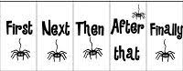 |  | We will be learning rhymes and patters to remember how to write numerals.  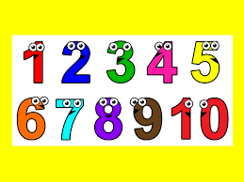 | We have Arts Week where as a school we will be learning songs and poems about Oceans.
For the next week on a rota basis we will be experimenting and exploring. Next week:

Honeybees will be exploring electricity – sorting electrical items and exploring ways to make a circuit.  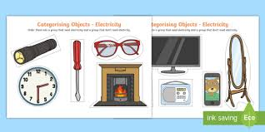 | Ladybirds will be exploring floating and sinking – predicting, observing and explaining  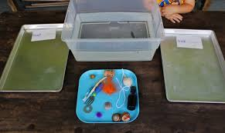 |  |  | Caterpillars will be exploring magnets -predicting and exploring things that are magnetic and non-magnetic.  