Activities based on the interests of the children….
We are going over all sounds from a – z.  We will be listening for sounds at the start of words.  We will be blending CVC words:  tap sat man pin | We will be learning about different types of transport:  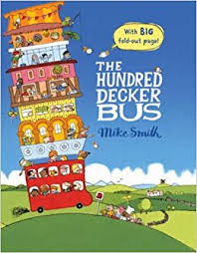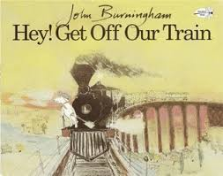 | We will be revisiting 1 more and 1 less and try to recall quickly 1 more or 1 less than a number:  What is 1 less than 5?  What is 1 more than 7?
We will be talking about time and how long journeys take.  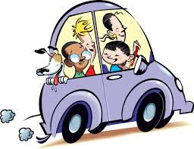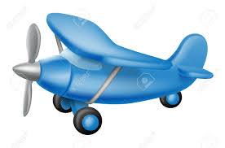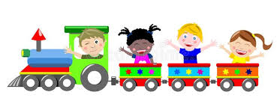 | We will be thinking about maps in more detail.  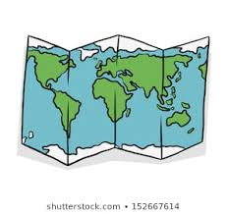 | We will be painting and making vehicles.  