Questions This Week:
What happened to the dinosaurs? WB: 11.2.19
We will be listening to each other talk about dinosaurs. Children can bring ion a book, pictures, dinosaurs – whatever they choose to. Please ensure that they are named.  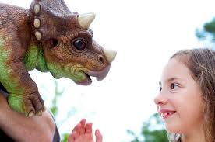 |  | We will have a ‘Dinosaur Workshop’ from Perform on Friday.
For the next two weeks on a rota basis we will be experimenting and exploring. Next week:

Honeybees will be exploring electricity – sorting electrical items and exploring ways to make a circuit.  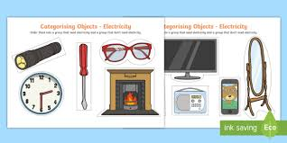 | Ladybirds will be exploring floating and sinking – predicting, observing and explaining  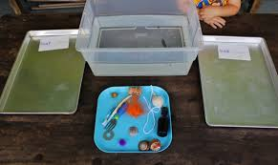 |  | Caterpillars will be exploring magnets -predicting and exploring things that are magnetic and non-magnetic.  