Question Of The Week: WB:1.10.18
What can we use our ears and sense of hearing for? What can we use our eyes and sense of sight for?
We will be reading Brown Bear, Brown Bear What Can You See?  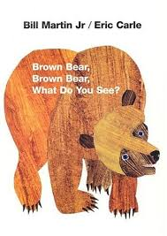 | We will be reading Polar Bear, Polar Bear What Can You Hear?  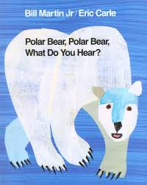 | We will be playing listening games such as:  - Copy Me – copying a clapping sequence  - Don’t Clap This One Back  - Go! – listen to an instruction but don’t do it until we say GO! Example Instructions 1. Stand up. Go! 2. Pat your head. Go!  - Fruit Salad  - Guess the instrument
We will be hunting in our foundation stage garden for sounds, numbers, signs of autumn and anything else that we think of…….  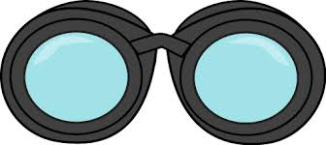 | We are learning about pattern:  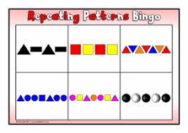 | We will continue to practise long ladder letters and curly caterpillar letters saying:  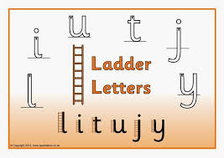start at the top, go down the long ladder and flick up at the end.  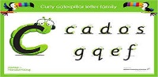 start at the caterpillars head, come back round under his tummy and curl up for his tail.
We will be continuing to discover the super learning powers that we all have, to reflect on our learning and think how we can make it better.  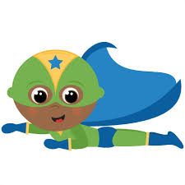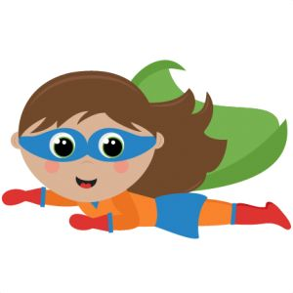 | Foundation Stage Harvest  4.10.18 at 9.30 in the school hall. We look forward to seeing you there. | We will be playing eye spy, spot the difference and looking at Where’s Wally Books.  