WB: 13.5.19 Are All Materials The Same?
We will be writing about our own recounts.  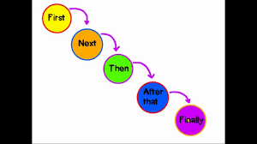 | We will be reading The Three Billy Goats Gruff and thinking about the troll.  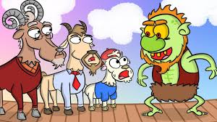 | We will be ordering leaves from the widest to the narrowest.  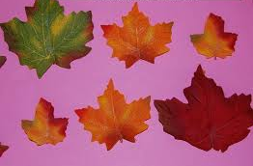
We will be asking if all materials are the same.  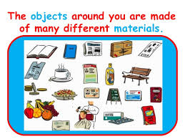 | We will continue to explore the part part whole model. | We will be learning to flange, slot, bend and make tabs when joining.  