SAFETY WEEK – FOUNDATION STAGE

Monday 31st October | We will meet Mrs West, the School Crossing Patroller, who will talk to us about Road Safety | We will have an anti-bullying assembly with Mrs Barnes | We will learn how to cross the road safely with Junior Road Safety Officers from Wendover Junior School  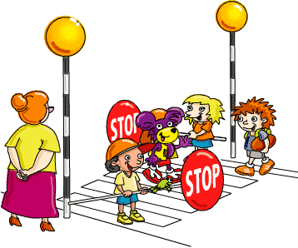 | At other times during the week, also linked to Safety Week, we will learn about:  - How to enjoy Halloween safely  - Medicine safety  - Stranger Danger  - Risk and Danger  - What would happen if…  - Resilience  - Safety through P4C
Tuesday 1st November | We will have a safety talk from two police officers
Wednesday 2nd November | We will meet Mr Nelson – a paramedic | We will learn about e-safety with Miss Nawaz
Thursday 3rd November | We will learn about safety around dogs in an assembly | We will learn about water safety with Liz Ward  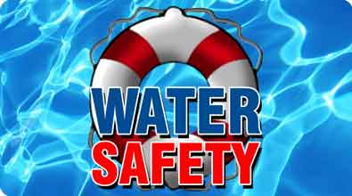 | We will have a ‘Taking Care of Myself’ assembly
Friday 4th November | We will learn about Firework Safety | We will learn about Fire Safety  