Question of The Week: WB: 11.11.19
How many different colours can you see around you?
We will be reading Brown Bear, Brown Bear  By Bill Martin Jr & Eric Carle.  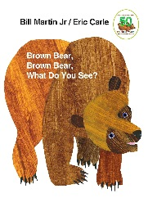 | In Maths we will be learning all about  Number  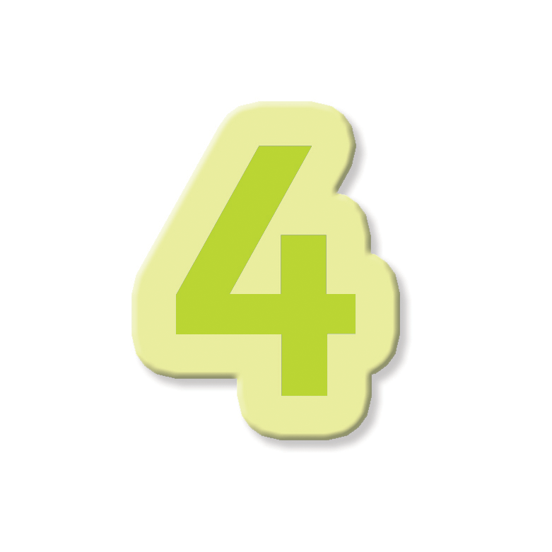  and ways we can represent the number through actions, mark making and counting. | We will be going on a colour hunt.  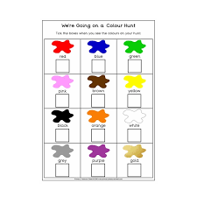
We will be choosing different colours to create pictures and learning how to colour mix.  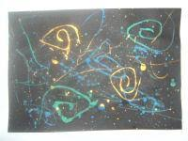 | We will continue to practise curly caterpillar letters saying:  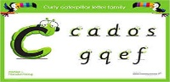  Start at the caterpillars head,  come back round under his tummy  and curl up for his tail. | In Computing we will be learning how to programme BeeBots  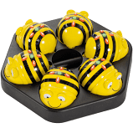
We will be thinking of ideas and working with others to grow ideas.  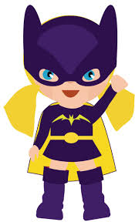 | We will be thinking of our own ideas and planning what to do. | We will start thinking about our Christmas play and learning the songs.  