Question Of The Week: How Do I learn? WB:30.9.19
Activities based on questions asked by children….
We will be learning all about our amazing bodies and which parts help us to learn.  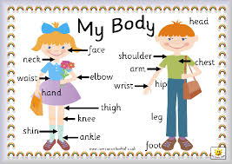 | We will be thinking and talking about different feelings we have.  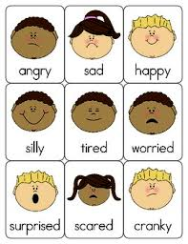 | We will be reading stories about ourselves and our bodies.  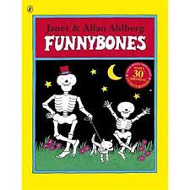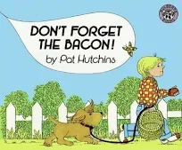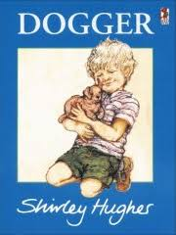
We will be playing listening games, rhyming games and orally blending games.  We will be listening for initial sounds.  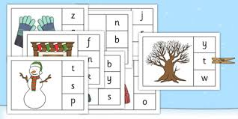  We will be matching words/ captions and pictures.  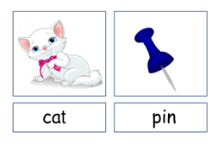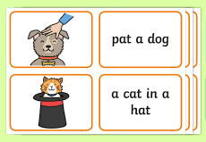 | We will be learning to:  - Count to 20 both forwards and backwards  - Say and use number names in rhymes and stories  - Count up to 10 moveable objects, then 20 from a larger quantity  - Match numerals to numbers of objects in a set  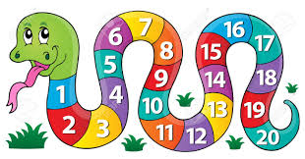 | We will be mark making and drawing patterns and shapes.  We will be learning about curly caterpillar letters, long ladder letters and one armed robot letters.  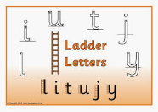  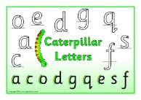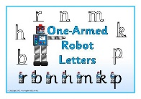
We will be discovering the super learning powers that we all have, learning how we grow our brain by challenging ourselves as well as persevering when things are tricky.  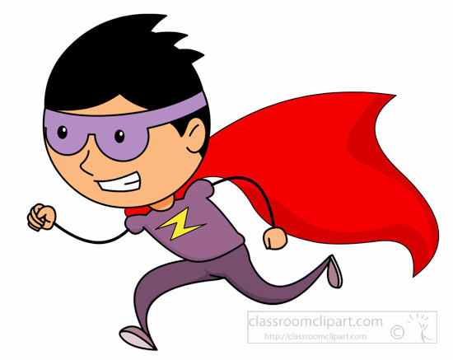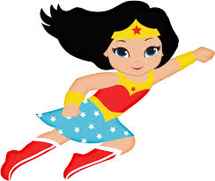 | PE is every Wednesday. | We will be hunting in our foundation stage garden for sounds, numbers, patterns, signs of autumn and anything else that we think of…….  