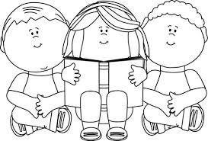 Book Review 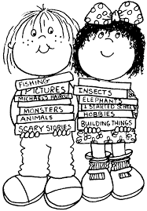
Title:

Did I enjoy the book?

What as my favourite part?

Who is my favourite character?

How did I feel about the book?

Character Description

