Question Of The Week: How Do I use different parts of my body to learn? WB: 07.10.19
Activities based on questions asked by children….
We will be exploring our senses to understand how they help us to learn.  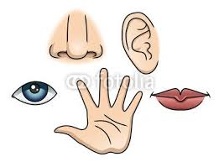 | As part of our topic, ‘Magical Me’, we will be drawing self- portraits.  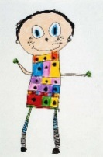 | We will be reading more stories about ourselves and our bodies.  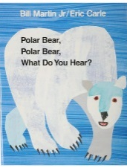
We will be playing listening games, rhyming games and orally blending games.  We will be introducing phonics;  s / a / t  We will be reading CVC words.  Look out for the 5 minute home sheets in the book bags to help with next week’s sounds. | We will be learning ‘All About One’. We want the children to:  - understand that number one is the first  number used when counting a group of  objects  - recognise that the numeral refers to a single  item and to be able to select 1 item from a  larger group  - be able to recognise 1 in different ways e.g. 1p  / 1 on a die / 1 numicon piece etc  -explaining reasoning  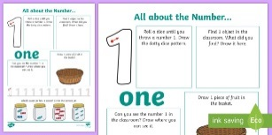 | We will be mark making and drawing patterns and shapes.  We will be learning about curly caterpillar letters, long ladder letters and one armed robot letters.  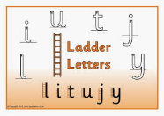  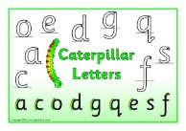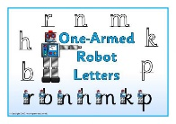
We will be continuing to use our super learning powers to challenge ourselves as well as persevering when things are tricky.  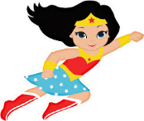  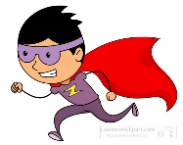 | PE is every Wednesday. | We will be hunting in our foundation stage garden for signs of Autumn.  