Questions This Week:
Why do animals have patterns? WB: 18.3.19
We will be writing instructions about how to draw different animals.  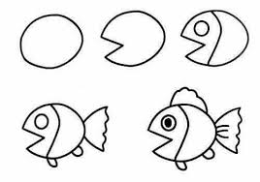 | We will be writing animal stories.  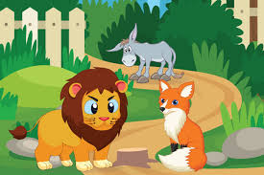 | We will be exploring patterns.  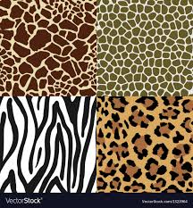
We will be continuing to explore repeating patterns.  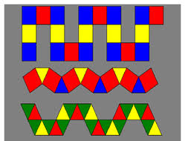 | We will be exploring symmetry.  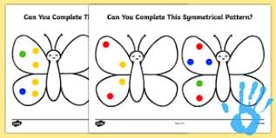 | We will be making pizzas.

