Theme of the week – Transition Dragon/Light and dark/Shadows
Activities based on the interests of the children….
This week we will be reading ‘When a dragon goes to school’, by Rosalind Beardshaw, in preperation for transitioning up to our new Foundation Stage classes.  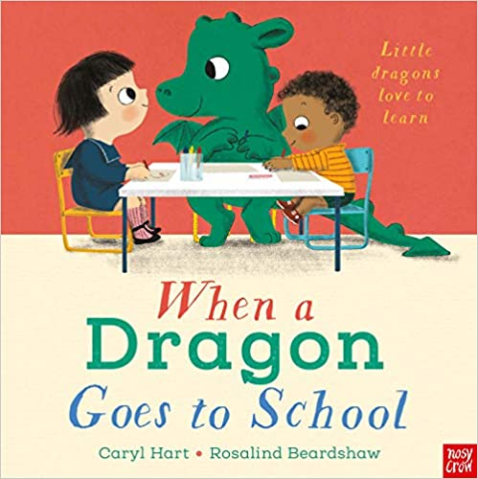  We will continue to follow our school value of Reflection and the behaviour expectation of Do be polite. | Our poem this week is called:  If I were so very small  If I were so very small,  I’d walk amongst the trees  And stretch to reach the top most leaf,  As easy as you please,  And if I were so very small,  I’d hide myself away,  And creep into a buttercup,  To spend a Summer’s day. | Our Number rhyme this week is 5 Green Bottles  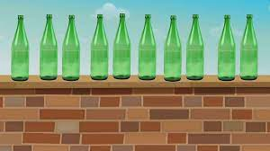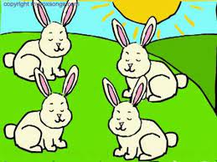  And this week’s Nursery rhyme is ‘Sleeping Bunnies’.  We will also be playing fun games such as ‘What’s the time Mr Wolf’ and Duck Duck Goose’.
We will be retelling stories that we alreay know using props and story maps  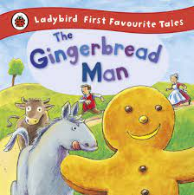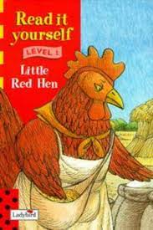 | This week we will be exploring light and dark and how shadows are made. We will be drawing some fun dinosaur shadow pictures on the ground outside and investigating light and dark using torches whilst inside dens that we have made.  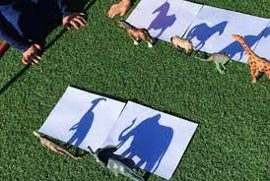 | We will be continuining to secure our number sense by subitising numbers to 5, reciting and reordering numbers 0-10, finishing the 5 on the five frame and developing our knowledge of part/whole with lots of fun and practical activities outside. We will also be recording what we see by mark making and drawing tally charts.  

