I can write a traditional tale Planes & Trains
Vocabulary  Grammar  Punctuation | . ? ! |  | uses tenses  I was  I am  I will |  | 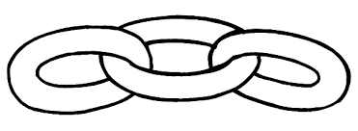  and but so or |  | if  when  that  because  who  which |  | Expanded noun phrases  lots of people |  | Capital letters at the beginning of names:  and places
,
for lists
 | “speech marks”
Spelling | spelling tricky words  the  was  - said  people |  | spelling first 100 words |  | Spelling mostly accurately (Segmenting and  spelling many of these words correctly and making phonically plausible attempts at others) |  | Suffixes  - ment, ness, ful, less, ly |  | there  their  they’re  check homophones and near homophones |  | ‘  don’t can’t  the cat’s name
 |  |  | spelling common exception words |  |  |  | Prefix  un  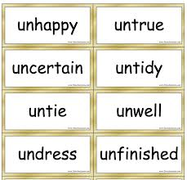
Handwriting | Joined writing  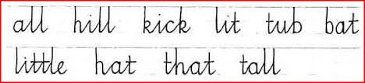 |  | Correct letter formation – lower case letters abc |  | Correct letter formation – upper case letters  ABC |  | Spacing between words |  |  |  | Paragraphs
Composition | - Plan writing  - Sequence ideas in a logical order  - Read what is written and say if it makes sense  - Proof read work, identifying some simple errors  - Revisit work to correct errors in punctuation – CL and FS  - Use intonation when sharing work and show an awareness of the readers  - Ensure that the tenses are used correctly  - Use word lists to check their spelling |  |  |  |  | - Begin to use notes and jottings to construct ideas  - Jot down words and ideas linked to themes  - Adopt different styles of writing when writing for different purposes – e.g. using the forms of letter  - Evaluate written work alongside the class teacher  - Identify what has been successful and where improvements are needed  - Take steps to address the areas of improvement with guidance  - Identify and modify written work to ensure it makes sense  - Use time verbs correctly within sustained pieces of writing
Effect on audience | 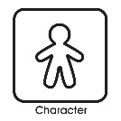  story start character | setting |  | 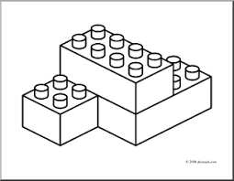  build up |  | problem |  | solution |  | start and ending
Onomatopoeia | Interesting, varied language:
Repetitive language:  Then I’ll huff and I’ll puff… | adverbs  for description |  | simile  …as…  …like… |  | alliteration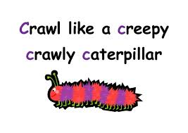 |  | Sentence openers  e.g. Once upon, Usually, Finally, Carefully |  | adjectives  physical features, personality

I can write a character description Lorries
Vocabulary  Grammar  Punctuation | AaBbCc . |  | ,  for lists | uses tenses  I was  I am  I will | and but so or | if  when  that  because  who  which | Expanded noun phrases  lots of people
 | ? !
Spelling | spelling tricky words  the  was  said  people |  | spelling first 100 words | Spelling mostly accurately (Segmenting and  spelling many of these words correctly and making phonically plausible attempts at others) | Suffixes  -ed, -es, -ing,  -ly  -er -est | Capital letters at the beginning of names:  and places
 |  |  | spelling common exception words
Handwriting | sit  tall |  | Correct letter formation – lower case letters abc | Correct letter formation – upper case letters ABC | Spacing between words
Composition |  |  |  | - Begin to use notes and jottings to construct ideas  - Jot down words and ideas linked to themes  - Adopt different styles of writing when writing for different purposes – e.g. using the forms of letter  - Evaluate written work alongside the class teacher  - Identify what has been successful and where improvements are needed  - Take steps to address the areas of improvement with guidance  - Read what is written and say if it makes sense  - Identify and modify written work to ensure it makes sense  - Use time verbs correctly within sustained pieces of writing  - Ensure that the tenses are used correctly  - Use word lists to check their spelling  - Use intonation when sharing work and show an awareness of the readers
- Plan writing
- Sequence ideas in a logical order
- Proof read work, identifying some simple errors
- Revisit work to correct errors in punctuation – CL and FS

Effect on audience | adverbs  for description |  | simile  …as…  …like… | alliteration | adjectives  physical features, personality | Interesting sentence openers  Sometimes, Quickly, If, When, Have you…?

I can write a character description Cars
Vocabulary  Grammar  Punctuation | AaBbCc . |  |  | uses tenses  I was  I am  I will | and but so or | because | Expanded noun phrases  lots of people
 | !
Spelling | spelling tricky words  the  was  said  people |  | spelling first 100 words | Spelling mostly accurately (Segmenting and  spelling many of these words correctly and making phonically plausible attempts at others) | Suffixes  -ed, -es, -ing,  -ly  -er -est | Capital letters at the beginning of names:  and places
 |  |  | spelling common exception words
Handwriting | sit  tall |  | Correct letter formation – lower case letters abc | Correct letter formation – upper case letters ABC | Spacing between words
Composition |  |  |  | - Begin to use notes and jottings to construct ideas  - Jot down words and ideas linked to themes  - Adopt different styles of writing when writing for different purposes – e.g. using the forms of letter  - Evaluate written work alongside the class teacher  - Identify what has been successful and where improvements are needed  - Take steps to address the areas of improvement with guidance  - Read what is written and say if it makes sense  - Identify and modify written work to ensure it makes sense  - Use time verbs correctly within sustained pieces of writing  - Ensure that the tenses are used correctly  - Use word lists to check their spelling  - Use intonation when sharing work and show an awareness of the readers
- Plan writing
- Sequence ideas in a logical order
- Proof read work, identifying some simple errors
- Revisit work to correct errors in punctuation – CL and FS

Effect on audience | adverbs  for description |  | simile  …as…  …like… | alliteration | adjectives  physical features, personality | Interesting sentence openers  Sometimes, Quickly, If, When, Have you…?

I can write a character description

 |  | AaBbCc | . |  | sit

spelling tricky words  the  was  said  people | spelling hf words  and  with  went  time | Segment to spell

I can write a character description Trains
Vocabulary  Grammar  Punctuation | . ? ! |  | uses tenses  I was  I am  I will |  | and but so or |  |  | if  when  that  because  who  which |  | Expanded noun phrases  lots of people | Capital letters at the beginning of names:  and places
,
for lists
 | “speech marks”
Spelling | spelling tricky words  the  was  - said  people |  | spelling first 100 words |  | Spelling mostly accurately (Segmenting and  spelling many of these words correctly and making phonically plausible attempts at others) |  |  | Suffixes  - ment, ness, ful, less, ly |  | there  their  they’re  check homophones and near homophones | ‘  don’t can’t  the cat’s name
 |  |  | spelling common exception words |  |  |  |  | Prefix  un
Handwriting | Joined writing |  | Correct letter formation – lower case letters abc |  | Correct letter formation – upper case letters  ABC |  |  | Spacing between words |  |  | Paragraphs
Composition | - Plan writing  - Sequence ideas in a logical order  - Read what is written and say if it makes sense  - Proof read work, identifying some simple errors  - Revisit work to correct errors in punctuation – CL and FS  - Use intonation when sharing work and show an awareness of the readers  - Ensure that the tenses are used correctly  - Use word lists to check their spelling |  |  |  |  | - Begin to use notes and jottings to construct ideas  - Jot down words and ideas linked to themes  - Adopt different styles of writing when writing for different purposes – e.g. using the forms of letter  - Evaluate written work alongside the class teacher  - Identify what has been successful and where improvements are needed  - Take steps to address the areas of improvement with guidance  - Identify and modify written work to ensure it makes sense  - Use time verbs correctly within sustained pieces of writing
 | Effect on audience Interesting, varied language:
adverbs  for description | simile  …as…  …like… | alliteration |  | Onomatopoeia |  |  | Sentence openers  e.g. Once upon, Usually, Finally, Carefully |  | adjectives  physical features, personality

