Stories From Around The World

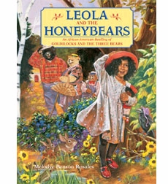 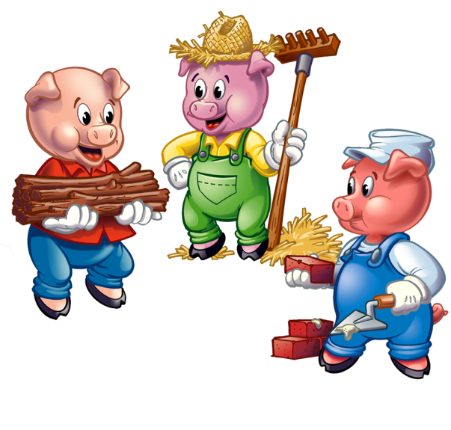

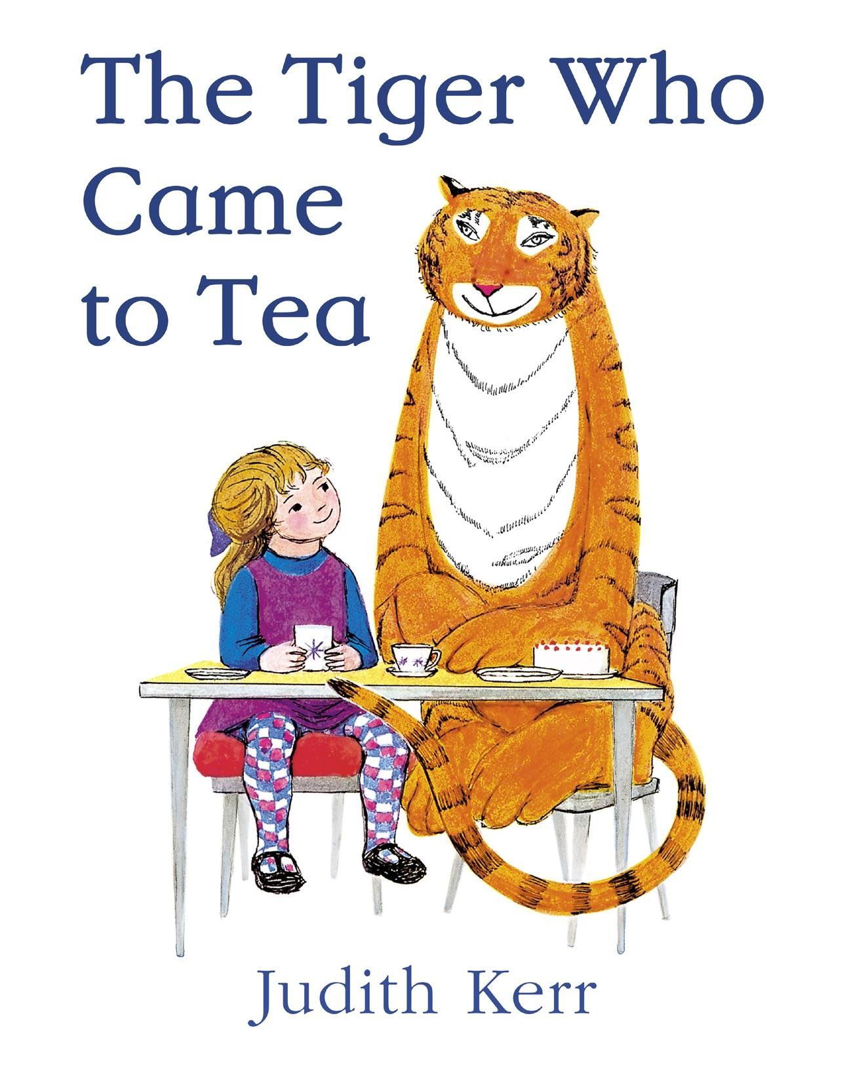

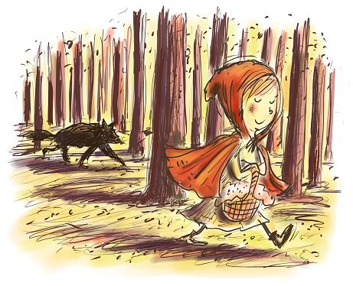 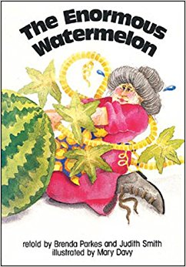

Foundation Stage Summer Term 2019

Learning Adventure

Our topic this term is ‘Stories From Around The World’. Throughout the term we will be looking at different stories, stories structures, story language, the messages behind them, the characters, caring, sharing and looking out for each other.

We cannot quite believe that this is our final term in the Foundation Stage. We have planned many exciting activities for the term, focused around stories. We will be organising a ‘The Tiger who came to Tea’ Day at school during the last half term.

During Summer 1 we will be learning about and reading lots of traditional tales as well as stories from different cultures as well as poems and nursery rhymes. We will then continue our story topic and Julia Donaldson will be our key author. If you have any favourite story books to share, please send them in with a name in the front or back and we will enjoy sharing them with the class. We will also have focus stories each week.

If you require any further information or have any concerns, please do not hesitate to talk to us.

Mrs Parkinson, Mrs Mills and Mrs Shrimpton

Activities to try at home....

* Read traditional stories, rhymes and poems and discuss messages – how it is important not to talk to strangers (Little Red Riding Hood)
* Discuss and describe characters from different stories
* Talk about where the stories take place
* Sequence the stories – what happens next?
* Make up your own stories-change the endings or the characters of familiar stories
* Make gingerbread men, measuring ingredients
* Make porridge
* Read stories from different cultures
* Search for different countries on maps and atlases
* Make tiger puppets or masks
* Design clothes for Cinderella or the Princess so they can go to the ball
* Create paper bag or kitchen roll fairy tale story characters

Useful websites:

<http://www.juliadonaldson.co.uk/>

<http://www.bbc.co.uk/cbeebies/stories>

<https://www.oxfordowl.co.uk/for-home/reading-owl/library-page>

Useful Information

Welcome back! We hope you have had a relaxing and enjoyable Half Term. Please find some information below which we hope you will find useful.

Reading is taught throughout the week in our class and group lessons and specifically during Group Time Sessions. Additionally, individual reading books are changed on a **Monday** and a **Thursday** by the class teacher and TAs who may also listen to your child read.

Please ensure your child has their reading book, home school dairy and book bag in school EVERY DAY.

Thanks You

Yoga and PE lessons will be on a Tuesday and Wednesday:

Please ensure your child has their PE kit at school ready for use. All clothing is clearly named.

Summer PE kit; blue shorts, white T-shirt, plimsolls or trainers.

Children can also wear tracksuit tops and bottoms.

|  |  |  |  |  |  |  |
| --- | --- | --- | --- | --- | --- | --- |
| Tues 23rd April  Inset Day | Tues 30th April  **Honeybees** Yoga with Mrs Grimsdale | Tues 7th May  **Caterpillars** Yoga with Mrs Grimsdale | Tues 14th May  **Ladybirds** Yoga with Mrs Grimsdale | Tues 21st May  **Honeybees** Yoga with Mrs Grimsdale | Tues 28th May  **HALF TERM** |  |
| Wed 24h April **All FS Classes** PE with Premier Sports | Wed 1st May  **NO PE – May Day dancing Assembly** | Wed 8th May **All FS classes**  PE with Premier Sports coach | Wed 15th May **All FS Classes**  PE with Premier Sports | Wed 22nd May **All FS Classes**  PE with Premier Sports | Wed 29th May  **HALF TERM** |  |
| Tues 4th June Inset Day | Tues 11th June **Caterpillars** Yoga with Mrs Grimsdale | Tues 18th June **Ladybirds** Yoga with Mrs Grimsdale | Tues 25h June **Honeybees** Yoga with Mrs Grimsdale | Tues 2nd July **Caterpillars** Yoga with Mrs Grimsdale | Tues 9th July **Ladybirds** Yoga with Mrs Grimsdale | Tues 16th July **Honeybees** Yoga with Mrs Grimsdale |
| Wed 5th June **All FS Classes** PE with Premier Sports coach | Wed 12th June **All FS classes**  PE with Premier Sports coach | Wed 19th June **All FS classes**  PE with Premier Sports coach | Wed 26th June **All FS Classes**  PE with Premier Sports coach | Wed 3rd July **All FS Classes**  PE with Premier Sports coach | Wed 10th July **All FS Classes**  PE with Premier Sports coach | Wed 10th July **All FS Classes**  PE with Premier Sports coach |

**Paediatric First Aiders In Foundation Stage**

Catherine Zucconi

**Managing Medicines**

Tracey Dale

**Allergens**

|  |  |  |  |
| --- | --- | --- | --- |
| **Mallable/creative** | **Containing Gluten** | **Sesame** | **Egg** |
| **Play dough** | **Wheat ✓** |  |  |
| **Pasta** | **Wheat ✓** |  |  |
| **Rice** | **Wheat ✓** |  |  |
| **Cooking** | **Containing Gluten** | **Sesame** | **Egg** |
| **This term we will be cooking a variety of different of different foods linked to our stories around the world and World Weeks.**  **Information of the relevant allergens will be sent out prior to the children cooking.** | | | |