Questions This Week:
Where did the dinosaurs live? WB: 4.2.19
We will be continuing to learn about dinosaurs and reading non-fiction and fiction books.  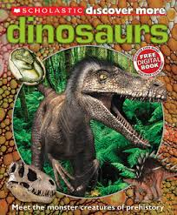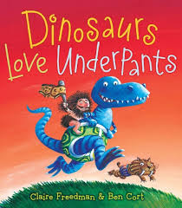 |  | We will be counting, counting totals of objects.  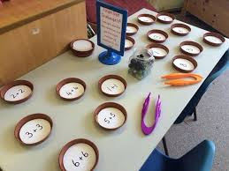 | We will be trying to write adding sentences.  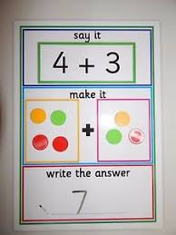
We will be drawing dinosaurs.  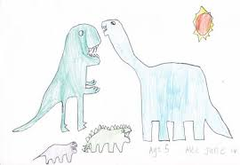 |  | We will be making silhouette pictures.  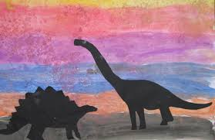 | We will exploring positional language:  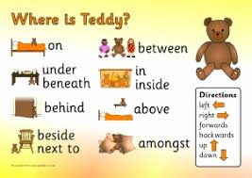
For the next three weeks on a rota basis we will be experimenting and exploring. Next week:

Honeybees will be exploring magnets – predicting and exploring things that are magnetic and non-magnetic.  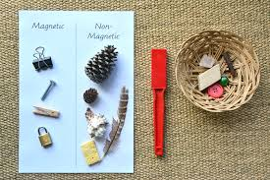 | Ladybirds will be exploring electricity – sorting electrical items and exploring ways to make a circuit.  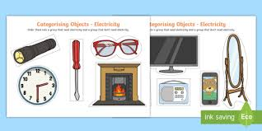 |  |  | Caterpillars will be exploring floating and sinking – predicting, observing and explaining.  