Question Of The Week: What can we use our hands and sense of touch for? WB:21.9.18

We will be learning all about the amazing things we can do with our hands.  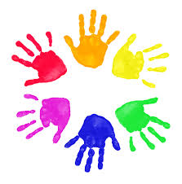 | We will be thinking and talking about kind hands.  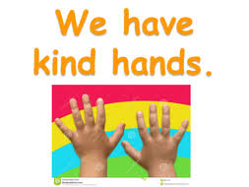 | We will be reading The Magic Paintbrush.  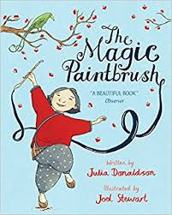  We will continue to make marks and draw patterns and shapes
We will be singing finger rhymes and using actions to help us to tell stories and say rhymes. | We are learning to count with accuracy by counting and touching objects as we count:  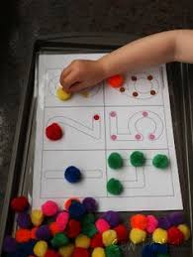 | We will be practising long ladder letters and curly caterpillar letters saying:  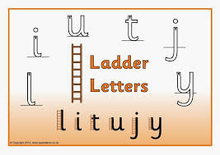start at the top, go down the long ladder and flick up at the end.  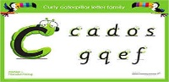 start at the caterpillars head, come back round under his tummy and curl up for his tail.
We will be continuing to discover the super learning powers that we all have, to reflect on our learning and think how we can make it better.  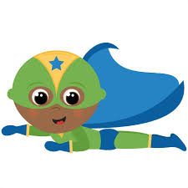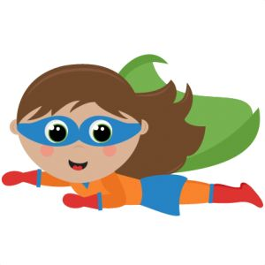 | PE is every Wednesday.  By the end of next week we will have all had a yoga session.  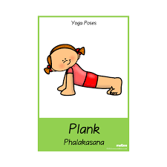 | We will be talking about the importance of washing our hands.  