Question This Week:

Were all dinosaurs the same? WB: 20.1.20

We will be looking at information books about dinosaurs and thinking about their similarities and differences.  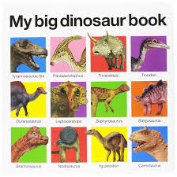 | We will be reading stories about dinosaurs.  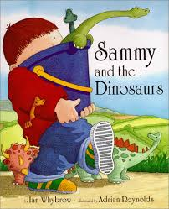 | We will be exploring magnets -predicting and exploring things that are magnetic and  non-magnetic.  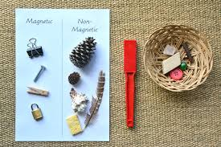
We will learning about different ways of joining including flanging. | We will be learning about number 8 and ways we can represent the number through actions, mark making and counting.  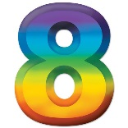 | In computing we will be using a paint programme to draw and write about dinosaurs.
We will be creating pictures of dinosaurs and using a variety of techniques to create a setting. We will be reflecting and seeing what we can do to make them even better.  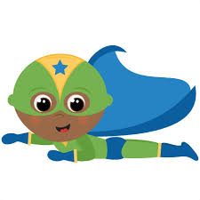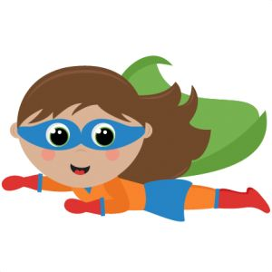 | We are talking about 2d and 3d shapes and the similarities and differences between them.  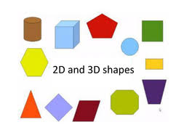 | We are writing for a range of purposes. The adults are reminding us to write a label for a model or instructions of how we made it.  