Year 2

Spring Term - 2

Learning

Through

Stories

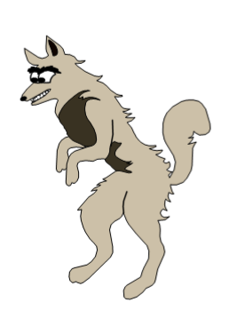



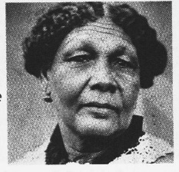

[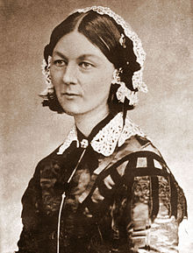](http://en.wikipedia.org/wiki/File:Florence_Nightingale_CDV_by_H_Lenthall.jpg)

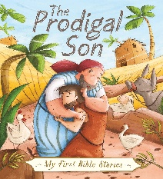 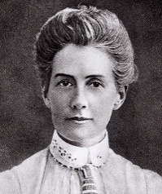

Useful Information

Please find some information below that we hope you will find useful.

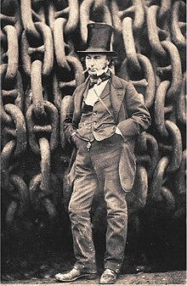Topic

[](http://en.wikipedia.org/wiki/File:Florence_Nightingale_CDV_by_H_Lenthall.jpg)The topic is “Learning through Stories”, with a strong emphasis on History. This will include looking at fiction and non-fiction texts and we are particularly focussing on comparing historical figures from similar fields, Edith Cavell, Mary Seacole and Florence Nightingale. We will be talking about Jesus as a famous person who taught through story telling and then the children will be listening to a variety of parables, including ‘The Prodigal Son’, 'The Good Samaritan' and ‘The Lost Sheep’. Next, we will make links between some of Jesus’ parables and our Golden Rules. We are encouraging the children to do research at home about any of these people and would be delighted if they bring their work into school to share. The classes will be planning, making & evaluating their own puppets following the popular visit by Joe the puppet man. These activities are linked to the subject of Design & Technology. In Geography sessions, the children will learn about St David & St Patrick. They will plot cities, rivers, seas & mountains on maps of Wales, Northern & Southern Ireland & then they will produce a detailed key.

English

We will read a wide range of Traditional Tales to help us to learn the skills required to write a story as well as a detailed character description. Additional skills will include using; a beginning, middle & end, writing in the past tense, verbs, adjectives, adverbs, conjunctions and expanded noun phrases. We shall continue to focus on presentation of writing, spelling, punctuation as well as grammar. The Talk for Writing approach to assist the children with memorising what they want to write, will also be continued.

The classes will also listen to & recite poems based on the different topics that we are learning about during this half term.

Maths

MC900130271[1]We will focus on multiplication and division during this half term and the children will be taught how to use repeated addition & arrays to help them with their calculations. They will be learning the 2, 5 & 10 times tables and they will also solve a range of related word problems. There will be a continued focus on learning multiples of two, three, five and ten as well as mental recall of number bonds to 20. The children will also complete practical activities and problem solving tasks linked to Money.

Please help your child with quick recall of number patterns and sequences. For example – counting forwards and backwards in 2s, 5s and 10s, starting at different numbers. Board games, practical experiences and any help with time and money will also be beneficial. Please do see your child’s teacher should you have any questions concerning how different Maths concepts are taught.

MC900234134[1]Spellings

The spelling routine continues in the same way, new ones will continue to be sent home weekly and tested each Friday. **It is vitally important that books are returned on a Friday so that your child may write the new spellings in**. The spellings will continue to follow a pattern of sounds which are linked to our daily taught phonic sessions. We advise a ‘little and often’ approach to learning them, throughout the week. We are expecting these words to be spelt correctly in any writing they do.

Reading

Children will continue to be heard by the Teacher or Teaching assistant each week. They will also be heard read during weekly Guided Reading sessions. Please try and hear your child read for at least 10 minutes every day, discussing their books with them and also asking appropriate questions about the text to help them to develop comprehension skills.

Phonics

This will continue to be taught daily in Year Two and will be referred to throughout all lessons. During these sessions, children are taught to blend to read and to segment to spell. Please do practise the spelling patterns in Phases 2-5, these can be found on the school website. Phase 6 will be taught in class, this focuses on grammar & punctuation, this half term learning will include; homophones & near homophones, plurals & suffixes.

Tricky & High Frequency Words

Each week during Phonics & English lessons, the classes will continue to practise reading & spelling High Frequency and Tricky words including the Year Two Common Exception Words. Please encourage your child to practise the words listed in the front of their Reading Diary.

Home/School Diary

We would like you to continue to complete the Home/School Diary on a daily basis. Please ensure you initial the book when you have heard your child read to enable us to change completed books on Tuesdays and Fridays. The children will not be allowed to change their books unless the diary is signed. **Please also check that your child fills in the “smiley faces”** as this gives us a strong indication of how they feel about their time in school and we can discuss any issues/concerns they might have. Teachers will also sign the diaries. If you have written any notes for us in the communication box please ensure your child shows them to the class teacher/teaching assistant on entry.

Homework

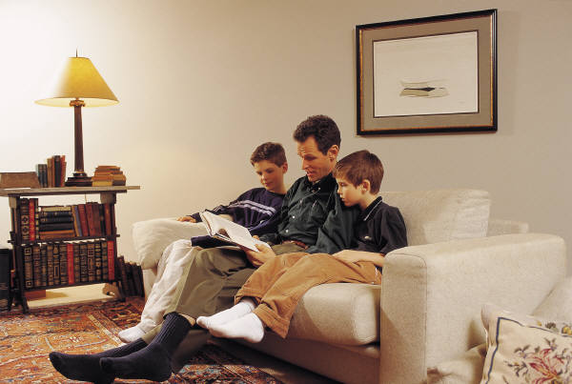In Year Two, we will continue to issue homework on a fortnightly basis except before a holiday. The timing enables children to work on and extend the homework as appropriate to their needs e.g. little and often over the fortnight or one or two longer sessions. We would now expect at least two pages of homework to be completed each fortnight.We encourage the children to use a range of approaches that might include research on the computer, photographs, diagrams and illustrations. Homework books are given out on a **Thursday** and it should be completed and handed in by the second **Tuesday**. Please ensure your child writes in pencil and that they present their work carefully. Please also make sure that the spelling of high frequency and tricky words are correct. If for any reason your child is unable to complete the homework set, do come and talk to the teacher or teaching assistant.

P.E.

P.E. lessons currently take place each Thursday and Yoga on Wednesdays, but may also take place at other times during the week. Please ensure that your child has an appropriate P.E. kit for sessions inside and outside. Also, please check regularly that their plimsolls or trainers fit appropriately. Please ensure that your child has an appropriate PE kit for sessions inside and outside – ALL NAMED, **this should include jogging bottoms or leggings and socks for girls who wear tights as part of their school uniform**, as some lessons take place outside. Boys and girls with long hair should have it tied back on P.E. days and earrings should be removed at home or they should have their own tape to cover earrings themselves before the P.E. lesson.

R.E.

The theme of Easter and its symbolism will be included as part of our work in R.E**.** We plan to learn about Palm Sunday and will hopefully have a visit by the Rev Sally Moring or Rev Nadine from St Mary’s Church. We will also be learning about special occasions including Passover linked to our focus on Judaism.

P4C

The children will complete a session on the difference between open & closed questions before going on to a discussion based on a chosen question. The classes will continue to use the terms ‘agree’, ‘disagree’ & ‘because’ and the focus will continue to be on developing the skill of persuasion. During this half term, we will be encouraging the children to develop ideas and to explore philosophical thinking related to enquiry in Science & Maths. These skills will help the children to develop their thinking and reasoning skills which they can apply to other areas of learning.

PSHE

The important theme of safety including internet safety will be revisited during this half term. We will also be learning more about friendship and family.

We will talk about our school values for this half term – perseverance, independence & collaborate. The children will set goals for this term and complete activities related to the above mentioned themes. Assemblies and Class Circle Times will be linked to the whole school focus, “Good to be Me”. The Year 2 representatives on The School Council will be meeting to discuss further ways to improve school life.

Computing

The classes will be using the Learn Pads to explore how games work and they will be creating a simple program to make their own games, building on algorithms from the Autumn term. We will also continue to emphasise the importance of staying safe while using a computer or tablet.

Music

The children will have weekly music sessions with Mrs Collins, based on listening & responding to high quality recordings of live music.

Art

Each class will produce collage, sculpture/models or paintings linked to the theme ‘Trash to Treasure’ and share what they have made with a buddy class during Arts Week.

Events/Activities

All Year Two classes thoroughly enjoyed our focus on Maths, Science & thinking during Discovery Week, just before half term. We will continue to focus on and use the different skills learnt to persevere with challenging activities that help us to develop resilience – the ability to cope when things don’t go as well as expected.

For those who missed the Maths Curriculum evening, the Presentation is available to view on the school website.

Do look out for information about our **worksharing afternoon**, this will take place on **Friday 13th March at 2.45 p.m.** It provides a wonderful opportunity for pupils to share their work and successes in learning with family members.

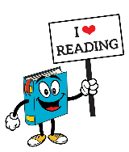As well as an exciting Arts week & Puppet day, Year Two are also looking forward to celebrating World Book Day with pupils from WJS. Please remember that the book swap box is located in the school lobby, the children are most welcome to take a book out in exchange for a book that they have put in.

Additional Information

Please note that there is a wide variety of information on the school website to help you to support your child with learning at home including a book review template should your child like to write about a favourite book that they have been reading at home.

As the cold weather continues, please provide your child with named coats, scarves, hats and gloves.

Your child may choose to bring a bottle of water into class. Please ensure that it is clearly labelled and **only** contains water.

**A polite reminder that holidays will not be authorised during term time and especially during the month of May as this is a very important assessment time in school for Year Two children.**

Finally, please do not hesitate to speak to members of the team if you have any concerns or questions, we are all here to help.

Thank you for your continued support and co-operation.

Yours sincerely

The Year Two team.

**Possible Activities To Do:**

Read a wide range of Traditional Tales & Poetry.

The Florence Nightingale Museum, London.

Claydon House, Middle Claydon to see Florence Nightingale artefacts.

BBC Schools website to research Edith Cavell, Mary Seacole and Florence Nightingale.

<http://www.bbc.co.uk/schools/primaryhistory/famouspeople/florence_nightingale/>

[http://www.florence-nightingale.co.uk](http://www.florence-nightingale.co.uk/) to find out about Florence Nightingale.