Questions This Week:
What is a minibeast? WB: 25.3.19
We will be listening to the story of The Hungry Caterpillar  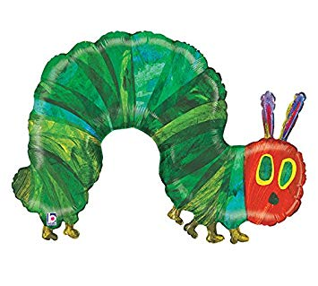 | We will be retelling the story and changing characters.  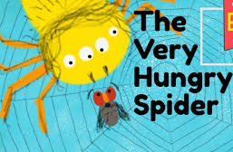 | We will be exploring lifecycles.  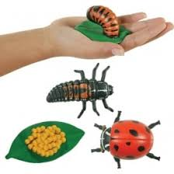
We will be counting forwards and backwards, counting in 2’s, 5’s and 10’s.  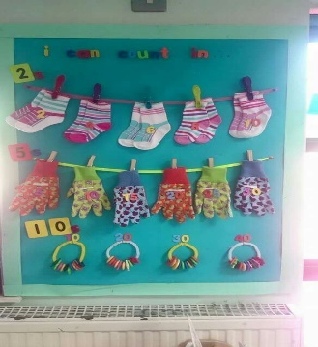 | We will continue to make symmetry.  We will be making symmetrical pictures.  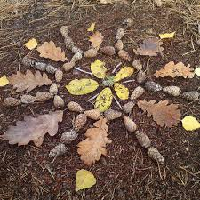 | We will be looking at doubles and doubling numbers.  