Year 2

Summer Term – 2

Down On The Farm

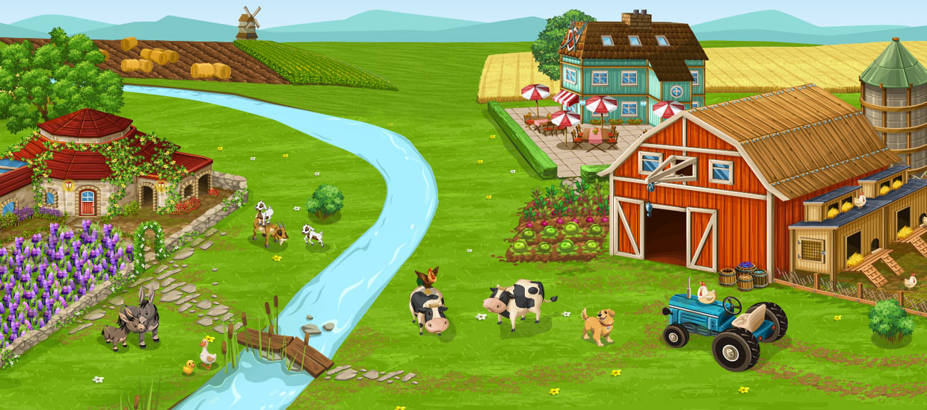

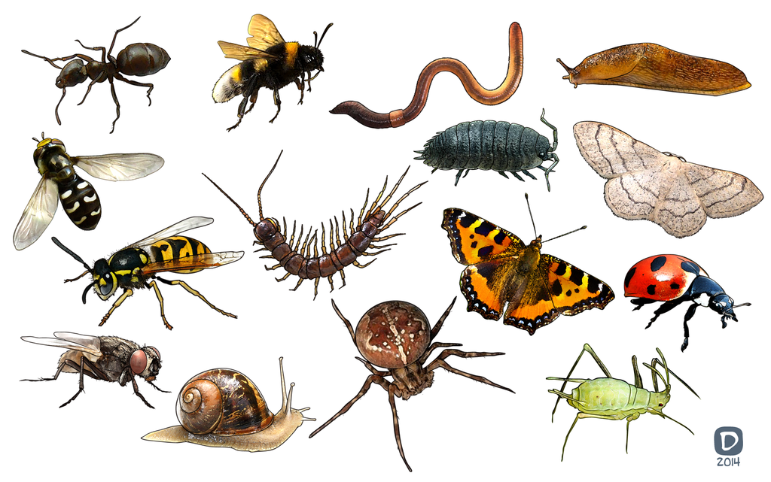 

Useful Information

It is hard to believe that we are in the last half term of this academic year. The children are becoming more independent and are impressing us with their mature attitude to life and learning at John Hampden. Please find some information below that we hope you will find helpful.

Topic

The topic is “Down on the Farm”, with the main focus being on Science & Maths. We will learn more about animals on our trip to Collings Hanger Farm and we will also study minibeasts and their habitats. We are sure that the children will have great fun making a wormery and observing it closely! The classes will collect data about minibeasts and they will collate tally charts & pictograms, answering simple questions about what they have found. They shall be re-creating the flower meadow that they will see at the farm, in the form of a colourful, sewn collage.

We start his half term with World Fortnight where each class will focus on a different country in order to learn about; making a comparison between Wendover an an area in their chosen country, human & physical features, traditions, food, clothes and religious customs. Each class will also conduct a P4C enquiry based on their learning. We will showcase the children’s related work on Open Evening in July.

English

English will involve learning how to plan and write a riddle linked to the outdoors, using the correct layout and we will continue to work on drafting and editing skills. We shall carry on with our focus on presentation of writing, spelling, punctuation as well as grammar. The Talk for Writing approach to assist the children with memorising what they want to write, will also be continued. There will also be opportunities for the classes to complete some free-choice writing too.

Maths

We will continue to focus on number, using addition, subtraction, multiplication and division skills taught to solve a range of problems. There will also be a focus on measure linked to our work on minibeasts, using standard units to measure height and mass as well as opportunities to compare and order lengths. The children will also learn to interpret and construct pictograms, tally charts, block diagrams and simple tables in our focus on statistics. We shall also complete some practical directional activities.



MC900234134[1]Spellings

The spelling routine continues in the same way, new ones will continue to be sent home weekly and tested each Friday. **It is vitally important that their books are returned on a Friday so that your child may write their latest spellings in**. The spellings will follow a pattern of sounds which are linked to our daily taught phonic sessions. Also we ask that the children continue to practise spelling the High Frequency and Tricky Words in their reading diaries as well as the Year 2 Common Exception Words (see under spelling section of school website). We advise a ‘little and often’ approach to learning them, throughout the week. We are expecting these words to be spelt correctly in any writing they do.

Reading

Children will be heard by the Teacher or Teaching assistant each week. They will also be heard read during weekly Guided Reading sessions. Please try and hear your child read for at least 10 minutes every day, discussing their books with them and also asking appropriate questions about the text to help them to develop comprehension skills.

Please note that there is a book review template available on the parents section of the school website. Should your child like to write about a particular book that they have enjoyed reading at home, we would be delighted to read about it.

Phonics

This will continue to be taught daily in Year Two and will be referred to throughout all lessons. During these sessions, children are taught to blend to read and to segment to spell. Please continue to practise the spelling patterns in Phases 2-5 with your child, the school website contains all spelling patterns. We will continue to work on Phase 6 phonics which focuses on grammar & punctuation, this half term learning will include; homophones, apostrophes for possession and in contractions, silent letters, plurals and further work on suffixes.

Tricky & High Frequency Words

Each week during Phonics & English lessons, the classes will continue to practise reading & spelling High Frequency and Tricky words including the Year Two Common Exception Words. Please encourage your child to practise the words listed in the front of their Reading Diary.

Home/School Diary

We would like you to continue to complete the Home/School Diary on a daily basis. Please ensure you initial the book when you have heard your child read to enable us to change completed books on Tuesdays and Fridays. The children will not be allowed to change their books unless the diary is signed. **Please also check that your child fills in the “smiley faces”** as this gives us a strong indication of how they feel about their time in school and we can discuss any issues/concerns they might have. Teachers will also sign the diaries. If you have written any notes for us in the communication box please ensure your child shows them to the class teacher/teaching assistant on entry.

Homework

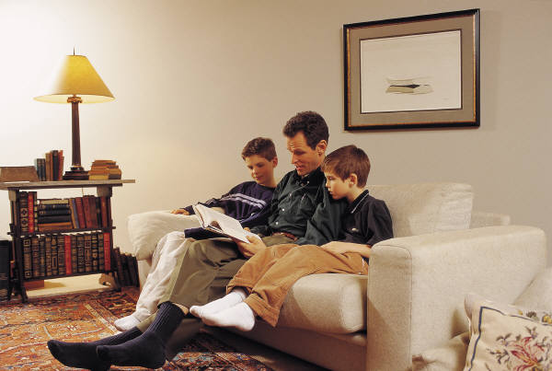During this half term, we will continue to issue homework on a fortnightly basis. The timing enables children to work on and extend the homework as appropriate to their needs e.g. little and often over the fortnight or one or two longer sessions. We would now expect at least two pages of homework to be completed each fortnight.We encourage the children to use a range of approaches that might include research on the computer, photographs, diagrams and illustrations. Homework books are given out on a **Thursday** and we expect it to be completed by the second **Tuesday**. Please ensure your child writes in pencil and they present their work carefully. Please also make sure that the spelling of high frequency and tricky words are correct. If for any reason your child is unable to complete the homework set, do come and talk to the teacher or teaching assistant.

P.E.

The focus during this half term will be on athletics in preparation for Sports Day. The children will continue to work towards achieving their marathon mile by jogging around the playground on a Friday morning.

P.E. lessons currently take place on Mondays and Wednesdays, but may also take place at other times during the week. Please ensure that your child has an appropriate P.E. kit for sessions inside and outside. Also, please check regularly that their plimsolls or trainers fit appropriately. Please ensure that your child has an appropriate PE kit for sessions inside and outside – ALL NAMED, **this should include jogging bottoms or leggings and socks for girls who wear tights as part of their school uniform**, as some lessons take place outside. Boys and girls with long hair should have it tied back on P.E. days and earrings should be removed at home or they should have their own tape to cover earrings themselves before the P.E. lesson.

D.T.

We will be designing and making our own farm vehicles based on the ones we’ll see at the farm, please look out for a letter about the provision of boxes ready for the project.

R.E.

The theme for the start of this half term will vary according to the class focus country, the classes will look at different artefacts, events, traditions and celebrations linked to their focus religion. We will also be learning about Judaism.

Growth Mindsets

The children will continue to be encouraged to use the tools presented in the ‘Great Learning Adventure’ to assist them with persevering in the face of a challenge whether it be a personal one or else one linked to learning.

PSHE

The whole school focus on “Changes” will follow the theme of transistion as we assist the children with their move up to new classes in September, there will be opportunities to visit their new school, to meet new teachers and to talk about related topics in circle times. Assemblies will help the children to explore the importance of looking ahead & of preparing for the new academic year. We will also talk about our school values for this half term – respect, independence, reflect & belonging. The children will set goals and complete activities related to the above mentioned values. The important theme of safety will be revisited again during this half term.

Computing

We are very excited about using the brand new bluebots to program instructions and create and follow our own algorithms.

Music

The classes will have weekly music sessions with Mrs Collins, based on following different patterns and rhythms, they will also learn a variety of songs to sing at the leavers assembly.

Events/Activities

Year Two visit to a garden in Wendover on 6th June, supporting our Science topics about plants, pollination & mini-beasts.

Year Two are also looking forward to our trip to Collings Hanger Farm, which will take place on 17th June (Herons & Red Kites) and 18th June (Firecrests).

Look out for details about Sports Day in the school newsletter.

Open Evening will be on July 11th 6-7pm.

Year Two parents are welcome to join us for the leavers assembly on Wednesday 24th July at 11.15.

Additional Information

Please note that there is a wide variety of information on the school website to help you to support your child with learning at home including a book review template should your child like to write about a favourite book that they have been reading at home.

You can also find information about how to support your child with transition to their next school.

Now that the weather has improved, please provide your child with a named sun hat. Rain coats will still be needed as the children do spend time outside on a daily basis. Please ensure that all items are named.

Your child may choose to bring a bottle of water into class. Please ensure that it is clearly labelled and **only** contains water.

Finally, please do not hesitate to speak to members of the team if you have any concerns or questions, we are all here to help.

Thank you for your continued support and co-operation.

Yours sincerely

The Year Two team.

**Possible Activities To Do:**

* http://www.bbc.co.uk/schools/parents/resources/ select the 4-7 age range and the area you are interested in (e.g. Maths, science etc.). This brings up a list of relevant activities/games you can choose from depending on your child’s interests.
* <https://www.woodlandtrust.org.uk/naturedetectives/> a wide variety of ideas for activities to do with your children to help them explore their local area and widen their knowledge of the natural environment.

Places to visit

* Farms and local parks to search for minibeasts and consider the awe and wonder of nature
* Wewndover Woods, Coombe Hill, Ashridge, College Lake, Tring Park
* Tring Museum