Questions This Week:
What do we know about dinosaurs? Are all dinosaurs the same? WB:28.1.19

We will be looking at information books about Dinosaurs.  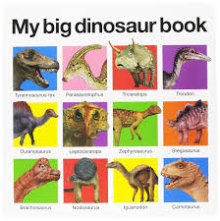 | We will be reading stories about dinosaurs.  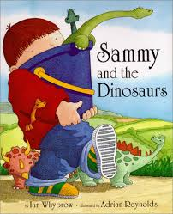 | We are learning how to be palaeontologists.  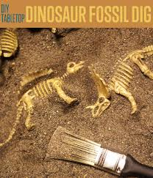
We are talking about shapes and the similarities and differences between them.  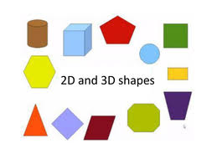 | We are talking about time and how we measure it. We will be racing using stop watches to see how long it takes.  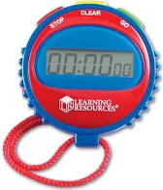 | We will be continuing to use money to pay for items in our pop up shops.
We are thinking of ideas and then use our ideas in a plan - Masters of Ideas and Dynamo Planners.
