Year 2

Summer Term - 1

In an English Country Garden

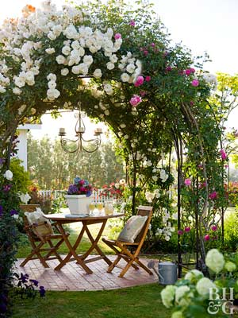

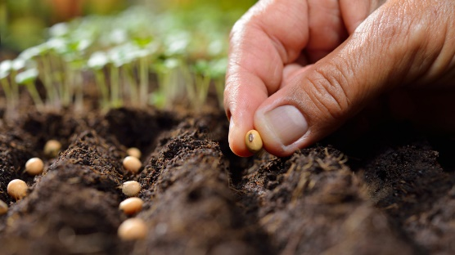 

Useful Information

Please find some information below that we hope you will find useful.

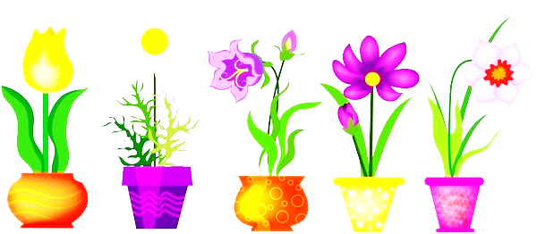Topic

The topic is “In an English Country Garden”, with the main focus being on Science. We will learn how to describe how seeds & bulbs grow into mature plants and the importance of pollination. We will also look at how plants need water, light and a suitable temperature to grow and stay healthy. The classes will also measure how plants grow and gather related data.

We will be encouraging the children to observe flower heads closely during our Art lessons. We will learn about the work of the artist, Georgia O’Keefe and will create our own illustrations by imitating her style of drawing.

Each class will conduct a P4C enquiry based on an area of interest linked to their work about plants.

With the theme of Spring in mind, Year Two are busy learning a maypole dance in readiness for the May Day celebrations.

In Geography sessions, we will learn about St George and find out how this Saint’s day is celebrated. We will plot cities, rivers, seas & hills on a map of England & we will also produce a detailed key.

English

English will involve learning how to plan and write letters using the correct layout and we will continue to work on drafting and editing skills. We will learn the conventions of and language required to write letters and the children will be encouraged to write their own using conjunctions and expanded noun phrases. We shall continue to focus on careful presentation of writing, spelling, punctuation as well as grammar. The Talk for Writing approach to assist the children with memorising what they want to write, will also be continued.

Maths

MC900130271[1]We will focus on revision of key skills taught this year in preparation for SATs in May. We shall re-visit the different methods taught including; repeated addition, arrays, grouping and the empty number line to help them with their calculations. The classes will also continue to solve a range of word problems and will be encouraged to provide reasons for particular answers. They will continue to practise number bonds as well as their times tables. There will be revision sessions about shape, symmetry, money, time & fractions. There will also be a focus on measure; using standard units to measure height and weight as well as opportunities to compare and order lengths. The children will also learn to interpret and construct pictograms, tally charts, block diagrams and simple tables in our focus on statistics.

MC900234134[1]Spellings

The spelling routine continues in the same way, new ones will continue to be sent home weekly and tested each Friday. **It is vitally important that their books are returned on a Friday so that your child may write their latest spellings in**. The spellings will follow a pattern of sounds which are linked to our daily taught phonic sessions. Also we ask that the children continue to practise **spelling** the High Frequency and Tricky Words in their reading diaries. We advise a ‘little and often’ approach to learning them, throughout the week. We are expecting these words to be spelt correctly in any writing they do.

Reading

Children will be heard by the Teacher or Teaching assistant each week. They will also be heard read during weekly Guided Reading sessions. Please try and hear your child read for at least 10 minutes every day, discussing their books with them and also asking appropriate questions about the text to help them to develop comprehension skills.

Please note that there is a book review template available on the parents section of the school website. Should your child like to write about a particular book that they have enjoyed reading at home, we would be delighted to read about it.

Phonics

This will continue to be taught daily in Year Two and will be referred to throughout all lessons. During these sessions, children are taught to blend to read and to segment to spell. Please continue to practise the spelling patterns in Phases 2-5 with your child, the school website contains all spelling patterns. We will continue to work on Phase 6 Phonics which focuses on grammar & punctuation, this half term learning will include; expanded noun phrases, homophones, work on tenses as well as further work on plurals & suffixes.

Tricky & High Frequency Words

Each week during Phonics & English lessons, the classes will continue to practise reading & spelling High Frequency and Tricky words including the Year Two Common Exception Words. Please encourage your child to practise the words listed in the front of their Reading Diary.

Home/School Diary

We would like you to continue to complete the Home/School Diary on a daily basis. Please ensure you initial the book when you have heard your child read to enable us to change completed books on Tuesdays and Fridays. The children will not be allowed to change their books unless the diary is signed. **Please also check that your child fills in the “smiley faces”** as this gives us a strong indication of how they feel about their time in school and we can discuss any issues/concerns they might have. Teachers will also sign the diaries. If you have written any notes for us in the communication box please ensure your child shows them to the class teacher/teaching assistant on entry.

Homework

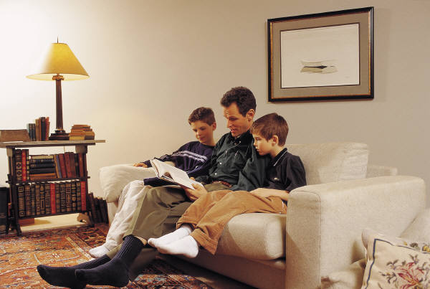During the Summer term, we will continue to issue homework on a fortnightly basis except before a holiday. The timing enables children to work on and extend the homework as appropriate to their needs e.g. little and often over the fortnight or one or two longer sessions. **We would now expect at least two pages of homework to be completed each fortnight.** We encourage the children to use a range of approaches that might include research on the computer, photographs, diagrams and illustrations. Homework books are given out on a **Thursday** and we expect it to be completed by the second **Tuesday**. Please ensure your child writes in pencil and they present their work carefully. Please also make sure that the spelling of high frequency and tricky words are correct. If for any reason your child is unable to complete the homework set, do come and talk to the teacher or teaching assistant.

P.E.

The focus during this half term will be on dance in preparation for the May Day assembly.

P.E. lessons currently take place on Mondays and Wednesdays but may also take place at other times during the week. Please ensure that your child has an appropriate P.E. kit for sessions inside and outside. Also, please check regularly that their plimsolls or trainers fit appropriately. Please ensure that your child has an appropriate PE kit for sessions inside and outside – ALL NAMED, **this should include jogging bottoms or leggings and socks for girls who wear tights as part of their school uniform**, as some lessons take place outside. Boys and girls with long hair should have it tied back on P.E. days and earrings should be removed at home or they should have their own tape to cover earrings themselves before the P.E. lesson.

R.E.

The theme this term will be Judasim and the classes will look at different artefacts, events, traditions and celebrations linked to this religion. We will also learn more about Ramadan and Pentecost in Cultural assemblies.

Growth Mindsets

The children will continue to be encouraged to use the tools presented in the ‘Great Learning Adventure’ to assist them with persevering in the face of a challenge whether it be a personal one or else one linked to learning.

PSHE

The important theme of safety will be revisited again during this half term.

We will talk about our school values for this half term – collaborate, manners & perseverance. The children will set goals for this term and complete activities related to the above mentioned themes. Assemblies and Class Circle Times will be linked to the whole school focus, “Relationships” where we shall explore the importance of friendship, getting on with others and what to do if we fall out. We shall also read a variety of Aesop’s Fables and interpret their morals.

Computing

The title of this half term’s unit is ‘We are Photographers’, it will involve the classes learning about webcams and their uses as well as gaining experience working with cameras. We will continue to emphasise the importance of e-safety at the start of every lesson.

Music

We are already learning a variety of songs to sing during the May Day assembly.

Events/Activities

The Year Two SATs meeting will take place during the first week back, on Thursday 25th April at 2.30pm.

Year Two parents are welcome to join us for the May Day assembly on Wednesday 1st May at 9.30.

The Year Two team are currently planning a visit to Collings Hanger Farm, which will take place in June. A letter with details of the trip will be sent out in the next few weeks.

Additional Information

Please note that there is a wide variety of information on the school website to help you to support your child with learning at home including a book review template should your child like to write about a favourite book that they have been reading at home.

When the weather finally warms up please provide your child with a named sun hat. Coats will still be needed as the children do spend time outside on a daily basis. Please ensure that all items are named.

Your child may choose to bring a bottle of water into class. Please ensure that it is clearly labelled and **only** contains water.

**A polite reminder that holidays will not be authorised during term time and especially during the month of May as this is a very important assessment time in school for Year Two children.**

Finally, please do not hesitate to speak to members of the team if you have any concerns or questions, we are all here to help.

Thank you for your continued support and co-operation.

Yours sincerely

The Year Two team.

**Possible Activities To Do:**

* [www.bbc.co.uk/gardening/gardening_with_children/](http://www.bbc.co.uk/gardening/gardening_with_children/)
* <https://www.bbc.com/bitesize/subjects/z6svr82> select the 4-7 age range and the area you are interested in (e.g. Maths, science etc.). This brings up a list of relevant activities/games you can choose from depending on your child’s interests.
* <https://www.woodlandtrust.org.uk/naturedetectives/> a wide variety of ideas for activities to do with your children to help them explore their local area and widen their knowledge of the natural environment.
* <http://www.sciencekids.co.nz>

Places to visit

Gardens open to the public (National Garden scheme booklet for information is available at the local library).

Pitt Rivers Museum, Oxford.

Wendover Woods, Ashridge Estate, Burnham Beeches, College Lake.

The Living Rainforest, Berkshire.

A Garden Centre or Nursery.