The John Hampden School Wendover

Annual Pupil Premium Report to Governors for Academic Year 2018-2019
The Pupil Premium is an element of school funding aimed at diminishing the difference in attainment of certain disadvantaged groups of pupils. It is calculated based on the number of children receiving free school meals, the number of ‘Looked After Children’ and the number of children from Service families. The Premium can be spent how the school decides and must ensure that standards are raised as a result of the spending,
The Ofsted inspection framework will have a particular emphasis on how well differences are diminishing both within the school and in comparison to national trends with specific reference to children eligible for the Pupil Premium.
In April 2018, for the financial year 2018-2019, our budget share allocated a total Pupil and Service Premium amount of £35,320 (approx. 4% of our overall revenue budget). Page 2 is a summary of the way we plan to use this funding to support our pupils’ learning. Our school’s pupil premium strategy will be reviewed annually and this report will be updated in September 2019.
(Note: Information related to individual pupils remains confidential)
PUPIL PREMIUM FSM Ever 6
Number of children eligible in January 2018 census: 16
Budget Allocation April 2018 = £21,120
This category includes any child that has been registered for FSM in the past 6 years (‘Ever 6 FSM’)
£1,320 per child eligible for FSM and per child identified as ‘Ever 6 FSM’
PUPIL PREMIUM SERVICE CHILDREN
Number of children eligible January 2018 census: 32
Budget Allocation April 2018 = £9,600
£300 per child of a service family
PUPIL PREMIUM PLUS LAC
Number of children eligible January 2018 census: 2
Budget Allocation April 2018 = £4,600
£2,300 per child
TOTAL Pupil Premium Grant allocation 2018-2019 = £35,320
Principles:
- We ensure that teaching and learning opportunities meet the needs of all pupils.
- We ensure that appropriate provision is made for pupils who belong to vulnerable groups, this includes ensuring that the needs of socially disadvantaged pupils are adequately assessed and addressed.
- In making provision for socially disadvantaged pupils, we recognise that not all pupils who are eligible for free school meals will be socially disadvantaged.
- We also recognise that not all pupils who are socially disadvantaged are registered or qualify for free school meals. We reserve the right to allocate the Pupil Premium funding to support any pupil the school has legitimately identified as being socially disadvantaged.
- Limited funding and resources means that not all children eligible for free school meals will be in receipt of pupil premium interventions at all times.
- Provision will not be aimed at teaching and learning for pupils with an EHC Plan as funding for need is already in place.
- It will be the responsibility of the Headteacher and the SCNC (Service Children Nurture Co-ordinator) to produce regular reports for the Governing Body about the impact of Pupil Premium Funding.
Academic Year 2018-2019
Summary of Plans for Pupil Premium spending Academic Year 2018/19
Main Barriers faced by eligible pupils:
- School readiness and ability to learn adversely affected by issues linked to behaviour management at home
- Negative effects of anxiety related to individual circumstances
- Distress caused by absence of parent/carer during deployment
- Disruption to learning caused by frequent relocation/moving schools
- Inequality of opportunity due to lack of learning support from home
- Isolation due to lack of family community links
- Limited opportunities for extra-curricular activities, activities outside school compared to their peers
- Perception of difference if uniform with school logo is not chosen
Planned spending objectives :
FSM
- To narrow the gap for those pupils not on track to make expected progress at the end of each year in Reading, Writing and Mathematics.
- To provide extra adult support to facilitate social and emotional development, 1-1 support and small group interventions for those children.
- To deliver additional, personalised learning opportunities for individuals
- To provide additional extra-curricular opportunities if required
- To provide support for parents in order for them to be able to support learning, behaviour and anxiety management at home
- To continue to employ Nurture/Support co-ordinator
- To provide items of uniform to aid inclusion
- To work collaboratively with local feeder pre-schools/families to ensure children are nurtured to become ‘school ready’
LAC
- To narrow the gap for those pupils not on track to make expected progress at the end of each year in Reading, Writing and Mathematics.
- To provide extra adult support to facilitate social and emotional development, 1-1 support and small group interventions for those children – these groups will involve other non-LAC
- To deliver additional, personalised learning opportunities for individuals – these groups will involve other non-LAC
- To provide additional extra-curricular opportunities if required

SERVICE FAMILIES
- Continue to employ Nurture/Support co-ordinator
- To accurately track changes in circumstances by developing appropriate methods of recording and sharing information
- To provide support and nurture for eligible pupils and their families
- To liaise with relevant agencies to share knowledge and expertise
- To ensure smooth transition for new and existing pupils as they join/leave the school
- To enable families to keep in contact during deployment
- To enable additional opportunities for pupils to receive additional 1-1/ small group support on their own or within groups including other children
- To reinforce a point of contact for Service families on the campus

These objectives have been chosen as they allow us to address the identified barriers faced by eligible pupils. The barriers and the associated objectives are reviewed annually but may be amended to meet the needs of any eligible pupil. The effect of the pupil premium will be measured through regular analysis of attainment and progress data for this group of pupils. Feedback from stakeholders, regular completion of pen profiles and on-going observations of children will provide us with further evidence of the effectiveness of pupil premium funding.

Previous Academic Year 2017-2018
PUPIL PREMIUM FSM
Number of children eligible October 2017 census = 20
Budget Allocation April 2018 = £26,000
This category includes any child that has been registered for FSM in the past 6 years (‘Ever 6 FSM’)
£1,300 per child eligible for FSM and per child identified as ‘Ever 6 FSM’
PUPIL PREMIUM PLUS LAC
Number of children eligible October 2017 census =2
Budget Allocation April 2018 = £3,800
£1,900 per child
PUPIL PREMIUM SERVICE CHILDREN
Number of children eligible October 2017 census: 32
Budget Allocation April 2018 = £9,600
£300 per child of a service family
TOTAL Pupil Premium Grant allocation 2017-2018 = £39,400

Summary of Pupil Premium spending 2017/18
Objectives in spending :
FSM
- To diminish differences for those pupils not on track to make expected progress at the end of each year in Reading, Writing and Mathematics.
- To provide extra adult support to facilitate social and emotional development, 1-1 support and small group interventions alongside other children
- To deliver additional, personalised learning opportunities for individuals on their own or within groups including other children
SERVICE FAMILIES
- To enable families to keep in contact during deployment
- To enable additional opportunities for pupils to receive additional 1-1/ small group support on their own or within groups including other children
- To reinforce a point of contact for Service families on the campus
- To facilitate links between service families and families of other children
- To purchase specific resources for use by service children and other children
- To provide a stimulating and informative interactive display to raise awareness for all staff and pupils
- To provide all pupils with a focus and a point of reference
LAC
- To diminish differences for those pupils not on track to make expected progress at the end of each year in Reading, Writing and Mathematics.
- To provide extra adult support to facilitate social and emotional development, 1-1 support and small group interventions for those children – these groups will involve other non-LAC
- To deliver additional, personalised learning opportunities for individuals on their own or within groups of other non- LAC

Summary of Pupil Premium spending/actions Academic Year 2017/18
Item/project | Cost  2017/2018 | Objective | Outcomes/Impact to date
FSM  Extra-curricular activities  School Visits  Individual support dependant on need | £30 voluntary contributions x20  + extra-curricular activities e.g. clubs  £800  TA Time/SLT Time  £2000 | To deliver additional, personalised learning opportunities for individuals | Objective met: FSM children have been clearly identified and necessary support has been organised. Positive feedback from parents
FSM  Social and emotional support | LSA Time  £4500 | To provide extra adult support to facilitate social and emotional development, 1-1 support and small group interventions | Objective met: Nurture group set up for vulnerable pupils.  Social Skills group set up for vulnerable pupils
FSM  Learning Support | TA Time  £6,900  LSA Time  £4500 | To narrow the gap for those pupils not on track to make expected progress at the end of each year in Reading, Writing and Mathematics. | Tracking information collected in Autumn, Spring and Summer Term.  Small numbers of FSM children and of these a significant proportion had SEN too.
FSM  Provision of School Uniform  Christmas Play Tickets | £2000 | To ensure parents are supported in providing children with appropriate clothing, equipment and support for school | Objective met: FSM children have been clearly identified and necessary financial support has been organised. Positive feedback from parents
LAC | TA Time  £1500  LSA Time  £2000 | To narrow the gap for those pupils not on track to make expected progress at the end of each year in Reading, Writing and Mathematics. | Tracking information collected in Autumn, Spring and Summer Term.  With additional support children were making better than expected progress.
LAC  Social and emotional support | LSA Time  £3,900 | To provide extra adult support to facilitate social and emotional development, 1-1 support and small group interventions | Objective met: Nurture group set up for vulnerable pupils.  Social Skills group set up for vulnerable pupils
TOTAL | £28,100
Item/project | Cost  2017-2018 | Objective | Outcomes to date
SERVICE  Pupil Support | Service Children Support Co-ordinator  £10,000  Teacher co-ordinator time  £200 | To enable additional opportunities for pupils to receive additional 1-1/ small group support | Objective met: evidence in the form of weekly feedback from SCSN co-ordinator reflects that Service children feel supported and settled in school. There is a clear communication route for children and their parents.
SERVICE  Family Support  Teacher support | Refreshments  £100 | To establish a point of contact for Service families on the campus | Objective met: Coffee mornings arranged for parents of Service children, some more well attended than others!
SERVICE  Raise profile of Service children in the school | SCSN co-ordinator time  £100 | To provide a stimulating and informative interactive display to raise awareness for all staff and pupils | Objective met: creation of a positive school atmosphere in which pupils’ differences are recognised and valued/understood within the school community.  Staff have a greater awareness of service families
SERVICE  Raise profile of Service children in the school | SCSN co-ordinator time  £800 | To provide pupils with a focus and a point of reference  Red, White & Blue Day  Bear Mascots | Objective met: Service children have an accessible focus/source of support.  Anecdotal feedback reflects a greater understanding within the school  Red, White and Blue day assembly run by SCSN co-ordinator and Teacher
TOTAL | £11,200

Total Pupil Premium received | £39,400
Total Pupil Premium expenditure | £39,300
Pupil Premium remaining | £100

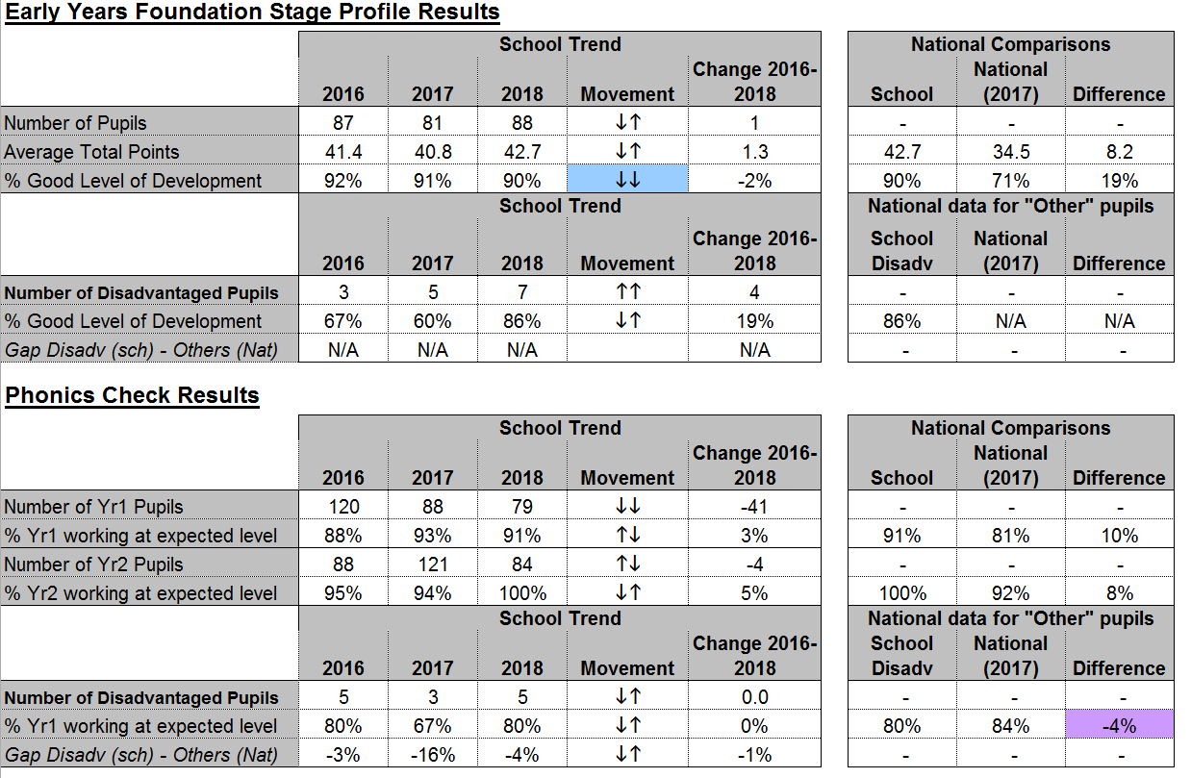
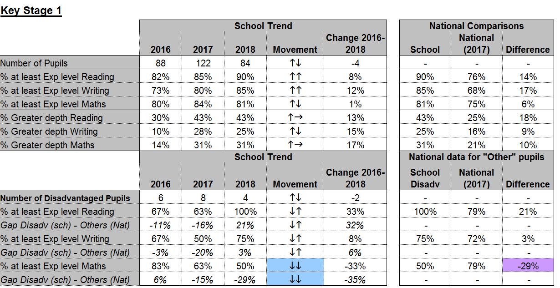

Sue Barnes September 2018
Next review of Pupil Premium Strategy: September 2019

