Question Of The Week: WB: 05.11.18
How many different colours can you see around you?
We will be reading The Crayon That Quit  By Oliver Jeffers.  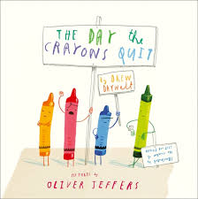 | We will be counting and adding  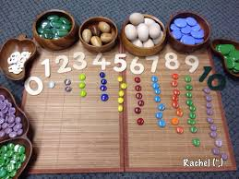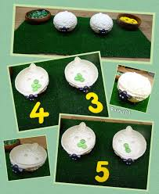 | We will be going on a colour hunt.  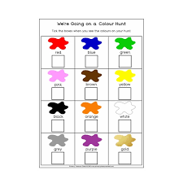
We will be choosing different colours to create pictures.  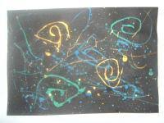 | We will continue to practise long ladder letters and curly caterpillar letters saying:  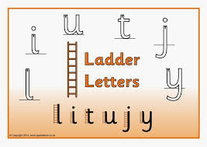start at the top, go down the long ladder and flick up at the end.  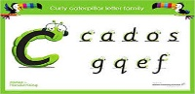 start at the caterpillars head, come back round under his tummy and curl up for his tail. | We will continue to practise the one armed robot saying:  Start at the robot’s head, go down his body and over his robot arm.  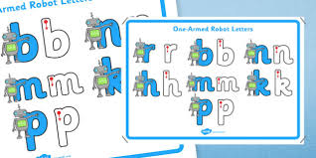
We will be thinking of ideas and working with others to grow ideas.  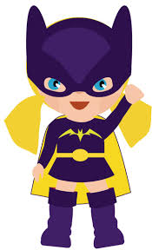 | We will be thinking of our own ideas and planning what to do.  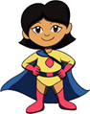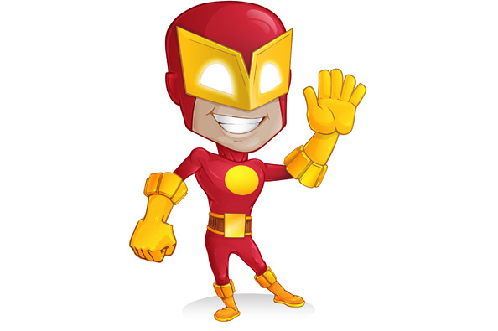 | We will start thinking about our Christmas play which is at the beginning of December.  