Question of the Week – Why do animals have patterns? How does it help keep them safe? WB: 16.03.20

We will be learning about halving and sharing and will practice cutting objects in half & quarters and sharing between friends.  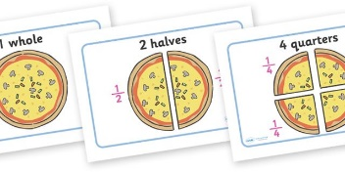 | We will be learning to combine 2 groups to find the whole and discuss our findings,  using mathematical language.  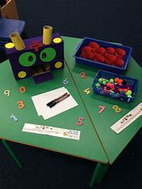 | We will be telling and writing stories using the Tales Toolkit.  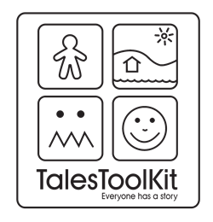
We will be exploring why animals have different patterns and how they help keep them safe.  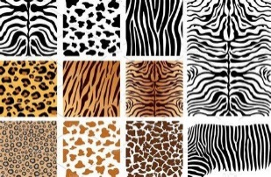 | We will be reading and re-telling stories, poems and songs about animals.  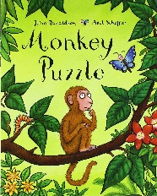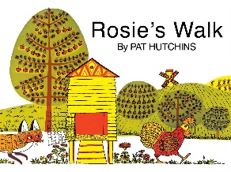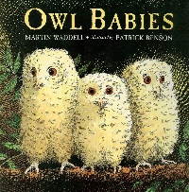 | We are continuing with a daily focus of learning to read and write our High Frequency Words. Please keep practising at home using the Phonics sheets.  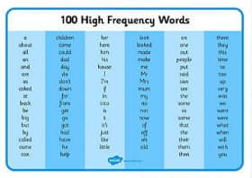
We will be creating animal camouflage pictures using pastels or water paints. We will be reflecting and seeing what we can do to make them even better.  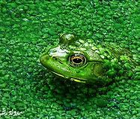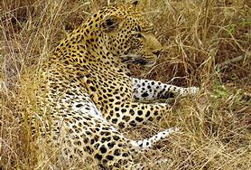 | As ‘Dynamo Planners’ we will be thinking of our own ideas and challenging ourselves to plan what we want to do and what we will need. | We are writing for a range of purposes. The adults are reminding us to write a label for a model or instructions of how we made it.  