Question of the Week – What can we find under the sea? Why is it important to re-use and recycle? WB: 24.02.20

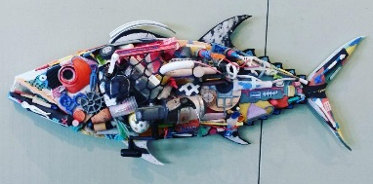  This week is Arts week. Our theme is Environmental Art – Trash to Treasure. | We will be discussing the impact we have on our environment and the importance of recycling.  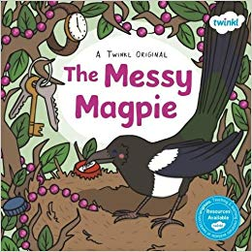  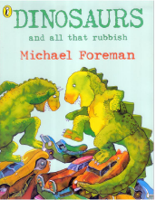 | We will be investigating what kind of creatures live ‘under the sea’ and choosing what we want to learn more about.  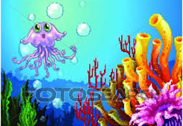
We will be learning about Shrove Tuesday.  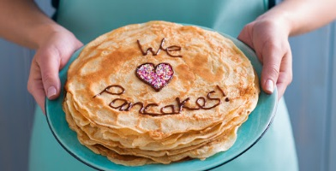 | We will be learning about symmetry and repeating patterns and making our own, both inside and outside.  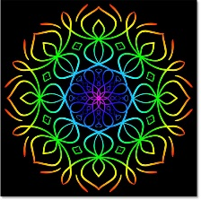 | We will continue to write for a range of purposes and will be practising writing our high frequency and tricky words.  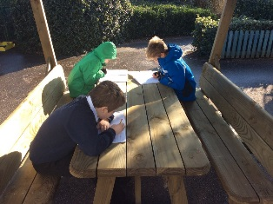
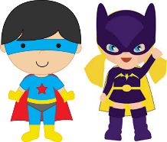  As ‘Masters of Ideas’, we will be thinking of our own ideas about how we can look after our planet by re-using everyday objects in our artwork and learning. | We will be reading and re-telling stories, poems and songs about our theme ‘under the sea’.  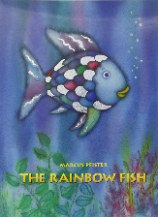 | As part of Arts Week, we will be exploring how we can use natural or recycled materials to make sounds/beat/music.  