Question Of The Week: How Do Colours Make Me Feel? WB:19.11.18

We will be learning all about how colours make us feel. | We will be building on our previous learning about feelings, thinking and talking about different feelings we have.  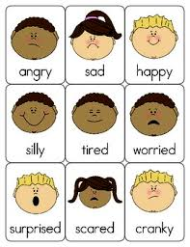 | We will be reading stories about colours and feelings.  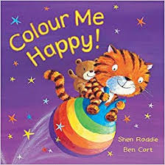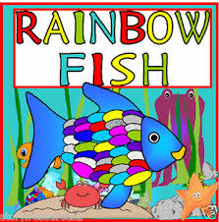
We will be talking about how we feel and play feelings games.  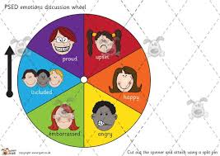 | We are learning to:  - Count one more and one less than an amount  - Say 1 more and one less than a number  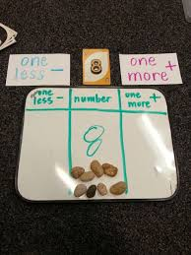 | We will be writing about The Little Red Hen.  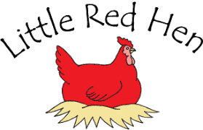
We will be weighing things that we find inside and outside and comparing them.  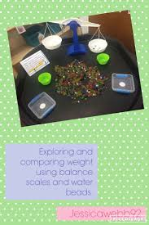 | We will be finding out about length and height, ordering and comparing.  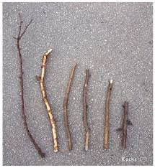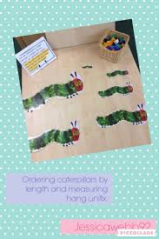 | We will be learning about capacity.  