Question Of The Week: What Can I Do To Keep Myself Healthy? WB:21.10.19

We will be looking at information books about keeping healthy.  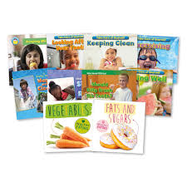 | We will be reading stories about keeping healthy.  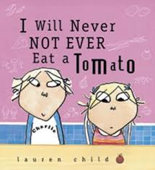 | Everyday we will be running or exercising for 5 minutes and observing the different effects on our bodies  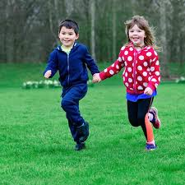
Early morning fitness session with Jodie Digby – all parents and children welcome – Tuesday 22nd October, 8.30- 8.45 am in the main playground.  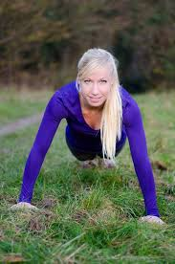 | We will be making fruit kebabs as a fruity snack. | We will meet a doctor who will talk to us about keeping well. We will be able to ask lots of questions.
We will be learning all about Number  and ways we can represent the  number through actions, mark making  and counting.  In handwriting we will be practicing one arm robot letters. | Please can children come to school everyday in clothes that are suitable for exercise.  Thank You | We will be talking about how to keep our teeth healthy and clean.  