Question Of The Week: What happens when you mix primary colours together? WB:12.11.18

We will be learning all about primary colours and what happens when we mix them together.  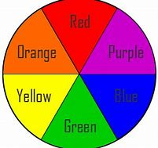 | We will be reading The Little Red Hen and acting out the story.  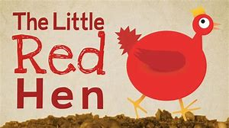 | We will learn the story with actions and then change some of the characters and parts of the story.  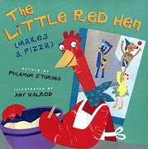
We will be continuing to learn our Nativity songs.  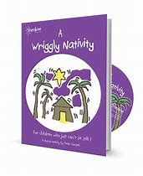 | We will be looking at Paul Klee pictures and recreating them….  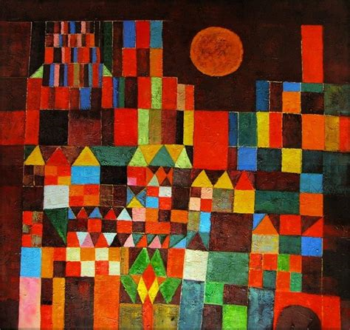 | ….and Andy Goldsworthy’s nature pictures.  