Question Of The Week: WB: 08.10.18
What part of our body do we use to explore our sense of smell and taste?
We will be reading Oliver’s Vegetables 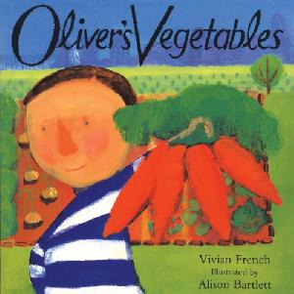  and talking about different foods. | We will be rereading and learning the story of Brown Bear,  Brown Bear What Can You See? Through a story map.  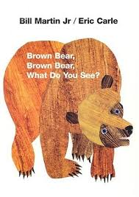 | We will be talking about animals with a keen sense of smell that have poor vision.  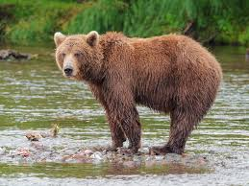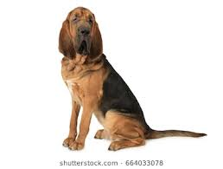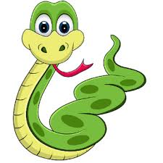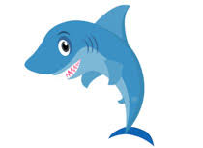
We are learning to play different number games including Numicon Bingo and Lego Tower Race Game.  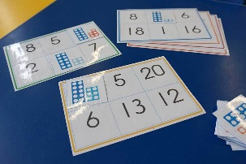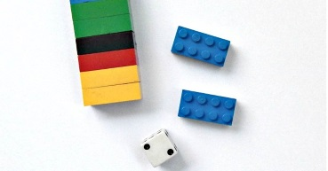 | We will continue to practise long ladder letters and curly caterpillar letters saying:  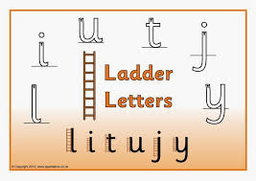start at the top, go down the long ladder and flick up at the end.  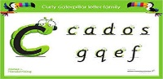 start at the caterpillars head, come back round under his tummy and curl up for his tail. | We will be learning the one armed robot saying:  Start at the robot’s head, go down his body and over his robot arm.  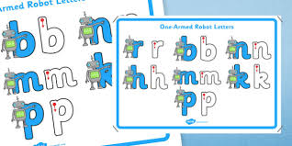
We will be thinking about how we are independent.  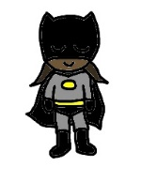  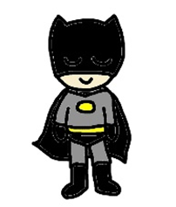  Secret Agents of Independence | We will be investigating different scents and smells.  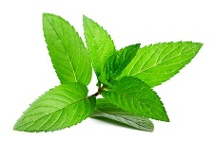 | We will change reading books on a Monday and a Thursday if there is a signature to say that books have been shared at home. Please ensure that books are in every day.  