Year 2
AutumnTerm - 1

Gobblefunk!

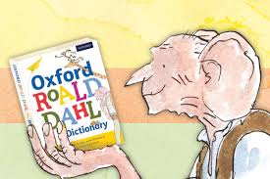
Useful Information
Dear Parents,
Many children are already coming into class independently and they are already settling well into the routines in Year Two. We are using this first half of the term to assist with their transition. We know that you are keen to know what your children will be learning and so we have attached an outline of the areas we will cover this term. Please note that we are using a topic based approach to teaching and learning.
English/Topic
Our topic for this first half term is ‘Gobblefunk!’ based on the inspirational author, Roald Dahl. The children will be hearing a range of stories which will incorporate the subjects of English, History, PSHE and R.E. Work in English will focus on narrative and sentence writing. We will look at lots of different fiction books to help us learn about the different parts of a story. We shall also focus on presentation of writing and punctuation as well as descriptive language. We follow a Talk for Writing approach in English where the children will learn the story and imitate it. Next the children innovate it by make changes to characters or the setting. Finally, the children will write and create their own invention based on what they have learnt in the unit.
Science activities will see us learn about the human life cycle and what our bodies need to be healthy. During Health week we will be writing instructions linked to making a healthy snack.
The focus in History will be on Roald Dahl as a significant person in our local area, we shall be reading information to find out more about him and his stories, the children will then produce information fact files about his life.

Maths
We will work on place value during this half term. We have started working on adding 10 to different amounts using a hundred square as well as learning multiples of two, three, five and ten. The children will also complete practical activities and problem solving tasks linked to geometry & measurement, the latter will involve them making their own ‘marvellous medicine’ to improve their understanding of capacity.

Spellings
Spellings will be sent home weekly and tested each Friday. The spellings will follow a pattern of sounds which are linked to our daily, taught phonic sessions. We advise a ‘little and often’ approach to practising them at home, throughout the week to support their learning. We are expecting these words to be spelt correctly in any writing. Please ensure that your child has their spelling book at school each Friday so that they may complete the quiz and write their new ones in.

Reading
Children will be heard by the Teacher or Teaching assistant each week. Please try and hear your child read for at least 10 minutes every day, discussing their books with them and also asking appropriate questions about the text to help them to develop comprehension skills.

Phonics
This will be taught daily in Year Two and will be referred to throughout all lessons. During these sessions, children are taught to blend to read and to segment to spell. Please continue to practise the spelling patterns in Phases 2-5, the school website contains all spelling patterns.
Tricky & High Frequency Words
The children will practise reading & spelling High Frequency and Tricky words each week in Phonics & English lessons.

Home/School Diary
We would like you to continue to complete the Home/School Diary on a daily basis. Please initial the book when you have heard your child read to enable us to change completed books on Tuesdays and Fridays. Please also check that your child fills in the “smiley faces” as this gives us a strong indication of how they feel about their time in school and we can discuss any issues/concerns they might have. Teachers will collect the diaries in each week to sign them. If you have written any notes for us in the communication box please ensure your child shows such notes to the class teacher/teaching assistant on entry.

Homework
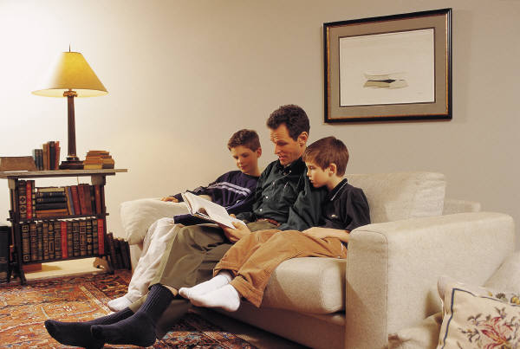
In Year Two, we will issue homework on a fortnightly basis. This allows the children to work on and extend the homework as appropriate to their needs e.g. little and often over the fortnight or one or two longer sessions. We would expect at least two pages of homework to be completed each fortnight. We encourage the children to use a range of approaches that might include research on the computer, photographs, diagrams and illustrations. The homework books are given out on a Friday and we expect the homework to be completed by the second Tuesday. Please can your child write in pencil and present their work as carefully as they can. Please also make sure that the spelling of high frequency and tricky words are correct. If for any reason your child is unable to complete the homework set please do come and talk to the teacher or teaching assistant.


P.E.
P.E. lessons currently take place on Mondays and Wednesdays but may also take place at other times during the week. Do ensure that your child has an appropriate P.E. kit for sessions inside and outside. Also, please check regularly that their plimsolls or trainers fit appropriately. Your child will need an appropriate PE kit for sessions inside and outside – ALL NAMED, this should include jogging bottoms or leggings. Boys and girls with long hair should have it tied back on P.E. days and earrings should be removed at home or they should have their own tape to cover earrings themselves before the P.E. lesson.

Design & Technology
This term all Year Two classes will plan and prepare their own healthy snack in the form of a fruity pick and mix during Health Week. They will also complete a linked evaluation sheet. Look out for the recipe in a newsletter nearer the time!
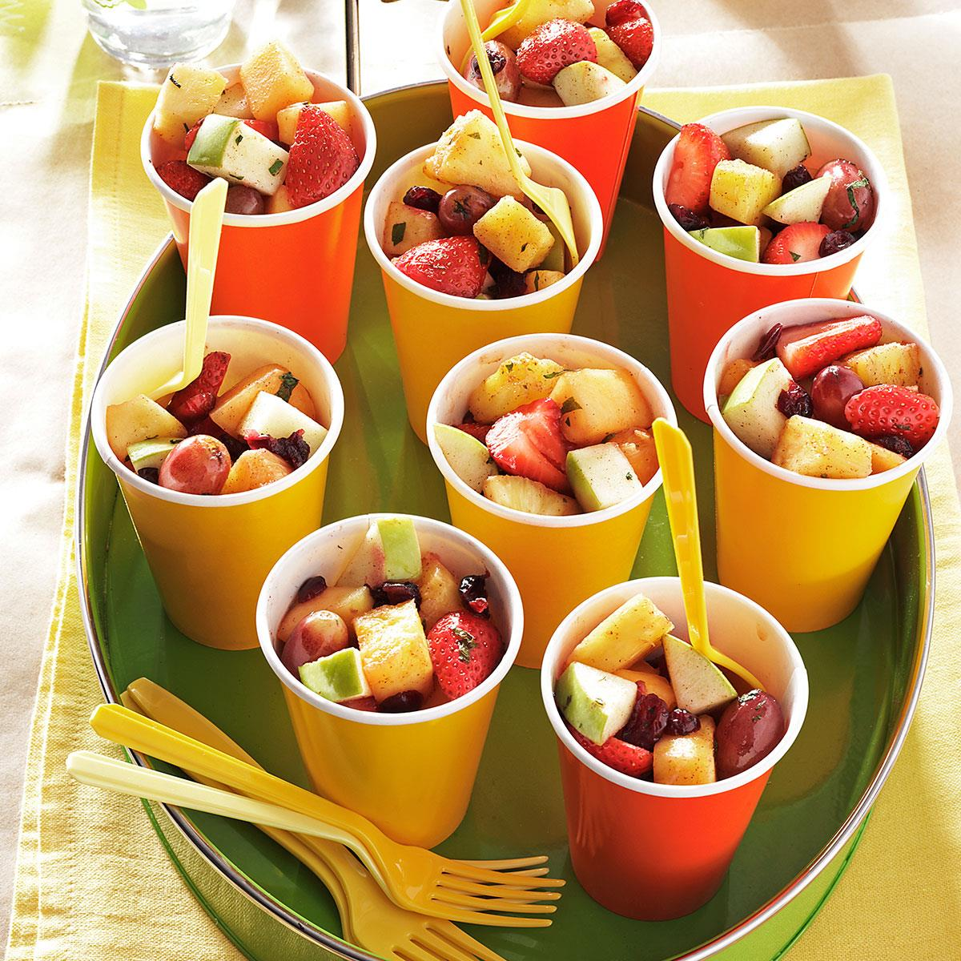

R.E.
During R.E. sessions, the children will think about places that are special to them. They will also listen to some parables from the Bible and consider their messages.
P4C
We will be introducing the Philosopher’s took kit to the children during this term. These skills will help them to develop their thinking and reasoning skills. We will focus on thoughts and concepts linked to different stimuli which will lead the children to vote for a question to discuss.

PSHE
We will talk about our school values for this half term – belonging, independence & reflection. The children will set goals for the half term and complete activities that promote collaboration and respect for others. We will also complete activities linked to the whole school focus on new beginnings.
Computing
The children will learn more about programming and algorithms using programmable toys and laptops. We will also continue to learn about the importance of e-safety.
Music
The children are busy learning songs, rhymes & poems ready for Harvest. Mrs Collins will teach them songs connected to the theme of Autumn.
Art
We will be using pastels to create observational drawings of fruit and vegetables. We will also complete art work linked to Quentin Blake’s illustrations in the stories written by Roald Dahl.

Events/Activities
Each Year Two class teacher will conduct a class induction talk over the next couple of weeks. If you are unable to attend, look out for the power point presentation available in your classes section on the school website.
Year Two are looking forward to visiting The Roald Dahl Museum in Aylesbury, the trip will take place on Monday 1st October.
Look out for information about Health Week which will take place during the last week before half term.
Additional Information
When the weather starts to turn colder, please provide your child with a warm, named coat. Your child is welcome to bring a water bottle into class, this should be clearly labelled and should only contain water.
Please note that holidays will not be authorised during term time and especially during the month of May as this is a very important assessment time in school for Year 2 children.
Finally, please do not hesitate to speak to members of the team if you have any concerns or questions, we are all here to help.
Thank you for your continued support and co-operation.

Yours sincerely
The Year Two team.

Useful websites
- http://www.bbc.co.uk/schools/parents/resources/ select the 4-7 age range and the area you are interested in (e.g. Maths, science etc.). This brings up a list of relevant activities/games you can choose from depending on your child’s interests.
- http://www.woodlandtrust.org.uk a wide variety of ideas for activities to do with your children to help them explore their local area and widen their knowledge of the natural environment.
- www.sciencekids.com
- www.roalddahl.com for a range of activities linked to Roald Dahl’s stories.

Places to visit
- Roald Dahl Museum – Great Missenden
- The Science Museum - London

