Questions This Week: We are continuing from last week……….
What animal am I? Where do I live? WB: 11.3.19
We will be writing clues about animals and trying to use adjectives to describe them.  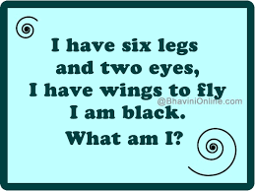 | Last week Animal Educate came. This week we are going to write about it.  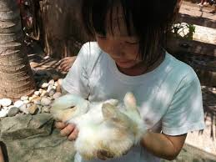 | We will be exploring the numbers 16-20  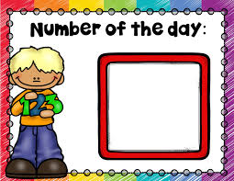
We will be exploring animal habitats and making animal homes outside.  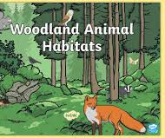 | On Monday we are having a tennis work shop. | On Thursday we are having a drumming work shop.

